Good afternoon XXX,
Congratulations on the purchase of your new vehicle!
My name is XXX from XXX and I will be organising the preparation of your new vehicle so you can take delivery shortly.
I have made available some important information below relating to the delivery of your vehicle with the Protektiv Premium Delivery Package. The Protektiv Package will enhance the everyday appearance of your new vehicle while also providing a lifetime warranty* for painted and interior surfaces.
Please compare the difference and watch the premium delivery ease-of-clean video. It’s really amazing how much of an enhancement can be added to your vehicle.
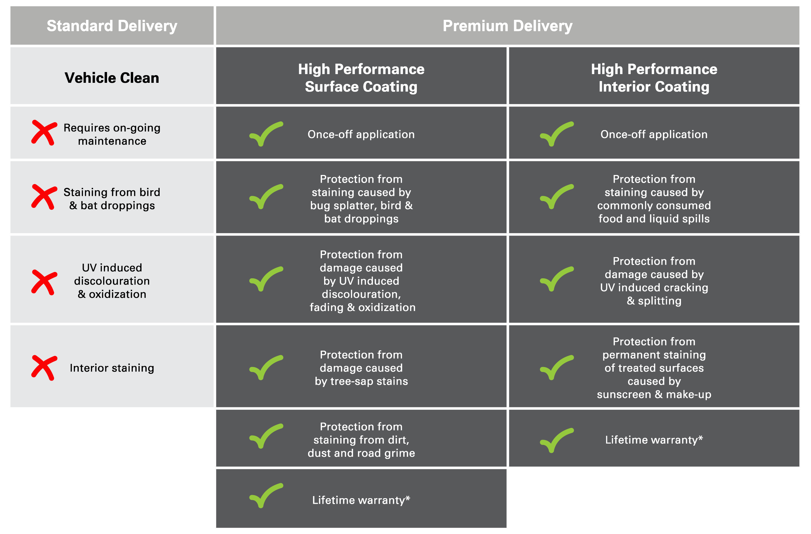
Protektiv Surface Protection  Protektiv has been found to be the ultimate prestige treatment to preserve and protect the paintwork and interior of your vehicle. Designed to ensure your vehicle retains that showroom shine over the period of ownership, this once-off permanent finish.  Watch this short video to see the product  in action. | 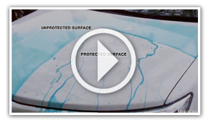
If you would like to add the Premium Protektiv Package to your vehicle, the individual cost and full package cost are as stated below:
The complete PROTEKTIV PACKAGE is great value - this month costing only $0000 plus all GST and Stamp Duty taxes. Included in the package are all lifetime, nationwide surface coating and UV protection film warranties*.
This full package includes: Individual Costings:
PROTEKTIV Exterior Surface Coating Valued at $0000
PROTEKTIV Leather Coating Valued at $0000
PROTEKTIV Fabric + Carpet Coating Valued at $0000
PROTEKTIV Vinyl Coating Valued at $0000
PREMIUM Darkest Legal Window Film Valued at $0000

We know that our customers like to take care of their new vehicles but free time in this day and age is honestly hard to come by. Our premium pre-delivery option gives you an ease of clean and a greater peace of mind by being covered with a national lifetime guarantee*.

Please advise how you would like me to proceed in preparing your vehicle for delivery.

Kind Regards,

[Name]
[Dealership Name]
[Address Details]
[Phone Number]
[Website address]

