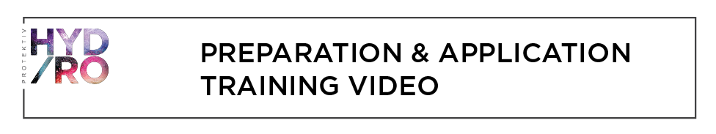
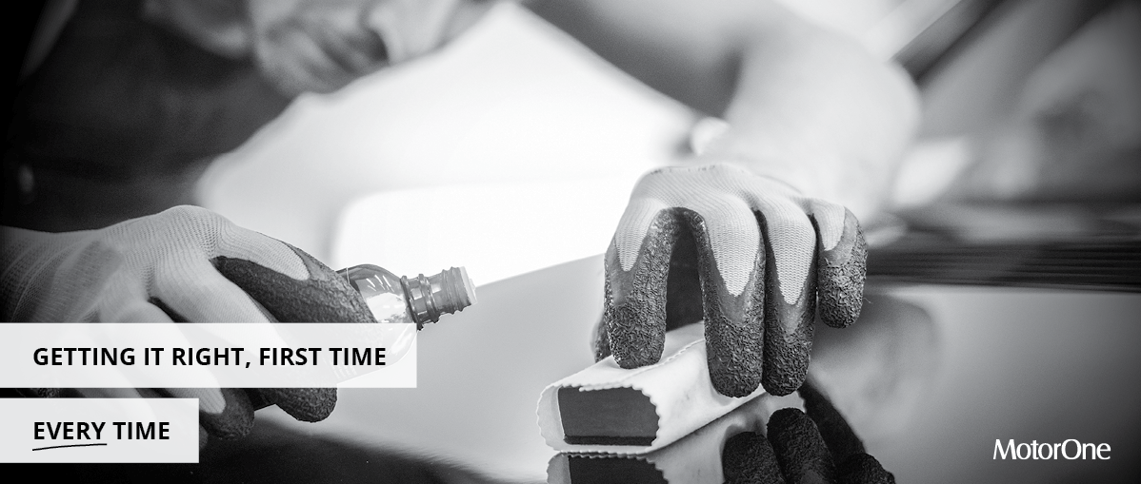
Good afternoon,
At MotorOne, we pride ourselves on providing best of breed products and delivering superior service to our dealer customers.
In an effort to provide outstanding service to the end customer investing in the products offered by MotorOne, we’ve put together this short training video to assist in making MotorOne’s application processes and procedures consistent every time.
We’ll demonstrate our tried and tested exterior and interior application techniques around applying surface protection product on customer’s vehicles. There’s also a few trouble shooting tips included to help get the best result every time.

Here’s what the video covers:  - Exterior paint application  - Fabric & carpet application  - Vinyl & leather application  - Wheel & headlight application  - And, trouble-shooting  WATCH THE VIDEO > | 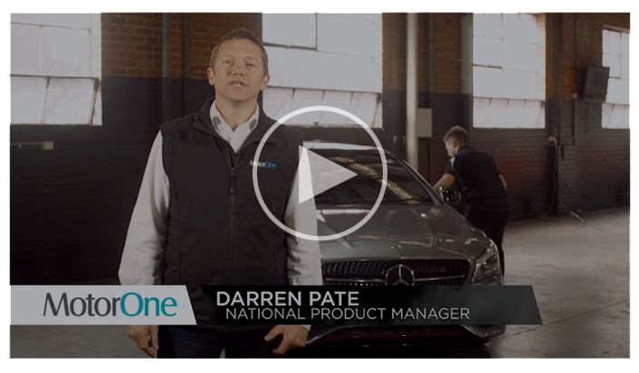
Have a question or feel you need more training support?
Contact your dedicated Account Manager who can assist further.

