Good afternoon XXX,
Congratulations on the purchase of your new vehicle!
My name is XXX from XXX and I will be organising the preparation of your new vehicle so you can take delivery shortly.
I have made available some important information below relating to the delivery of your vehicle with the Reload delivery package.
Reload is a rejuvenation and protection program for pre‑owned vehicles between 12 months and 10 years old. It’s designed to ‘reload’ your vehicle to the purest shine, using environmentally friendly, water-based formulas. It also comes with a pro-rata warranty* for vehicles
up to 10 years old, with no annual inspections or re-applications needed.
Add gloss and shine back to your vehicle  The process of application involves diagnosis of the paintwork by a trained technician, then deep-cleaning using the RELOAD preparation process to remove oxidisation and pollutants.  The paintwork is then prepared by removing micro surface marks  which helps restore paint gloss - this is the key to RELOAD.  RELOAD restores gloss and shine, creating superior protection against damaging UV and environmental contaminants.  Watch this short video to see the product in action. |  | 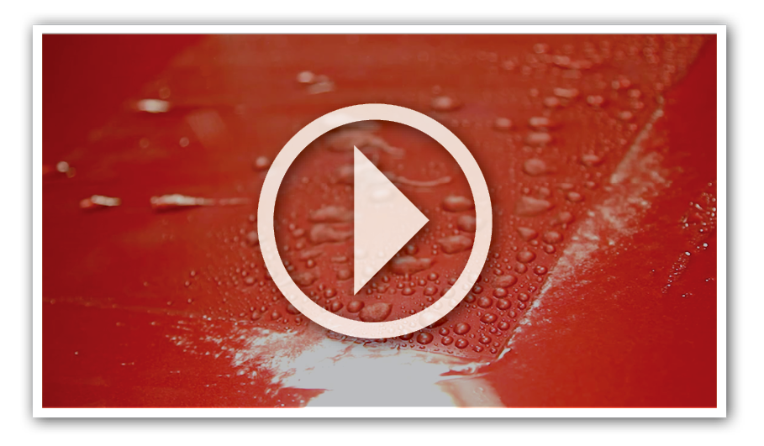
If you would like to add the Reload Delivery Package to your vehicle, the individual cost and full package cost are as stated below:
The complete package is great value - this month costing only $0000 plus all GST and Stamp Duty taxes.
This full package includes:  RELOAD Paint Surface Coating  RELOAD Leather Coating  RELOAD Fabric + Carpet Coating  RELOAD Vinyl Coating  PREMIUM Darkest Legal Window Film | Individual Costings:  Valued at $0000  Valued at $0000  Valued at $0000  Valued at $0000  Valued at $0000
We know that our customers like to take care of their new vehicles but free time in this day and age is honestly hard to come by. Our premium pre-delivery option gives you an ease of clean and a greater peace of mind by being covered with a national guarantee*.

Please advise how you would like me to proceed in preparing your vehicle for delivery.

Kind Regards,

[Name]
[Dealership Name]
[Address Details]
[Phone Number]
[Website address]

