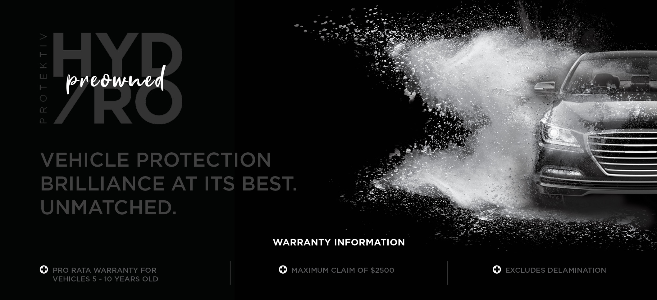
Hello [insert Customer first name]

Congratulations on owning your new < Vehicle Name >!

My name is < Insert Name > from < Dealership Name >. I work closely with < insert sales person’s name > and help in the organisation and preparation of your new vehicle so you can take delivery shortly.

I have made available some important information below relating to the delivery of your vehicle with the HYDRO Preowned Premium Delivery Package.

Please compare the difference and watch the premium delivery ease-of-clean video. It’s really amazing how much of an enhancement can be added to your new vehicle.
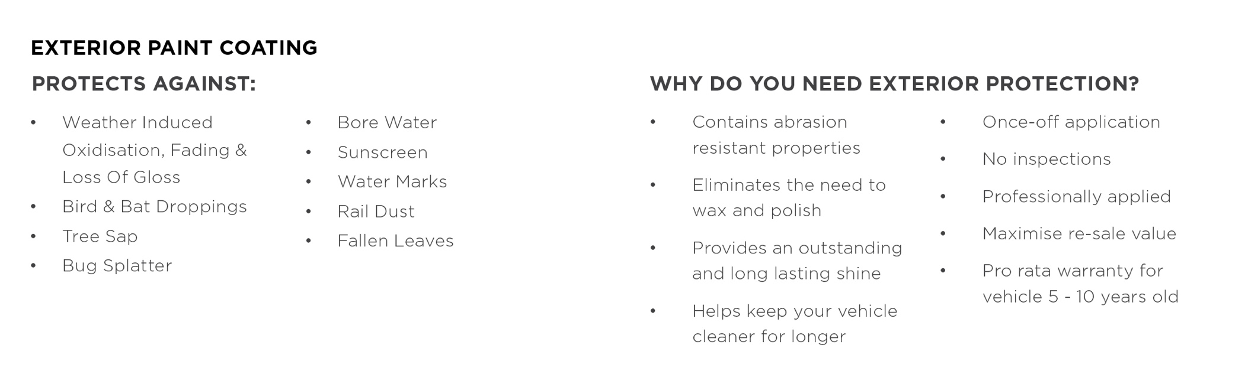
Protektiv HYDRO Preowned  Protektiv HYDRO Preowned has been found to be the ultimate prestige treatment to preserve and protect the paintwork and interior of your vehicle.  A Silicon Carbide (SiC) base gives the highest gloss and hydrophobic properties to help repel anything that gets thrown at it.  Designed to ensure your vehicle retains that showroom shine over the period of ownership, this once-off permanent finish.  Watch this short video to see the product in action. | 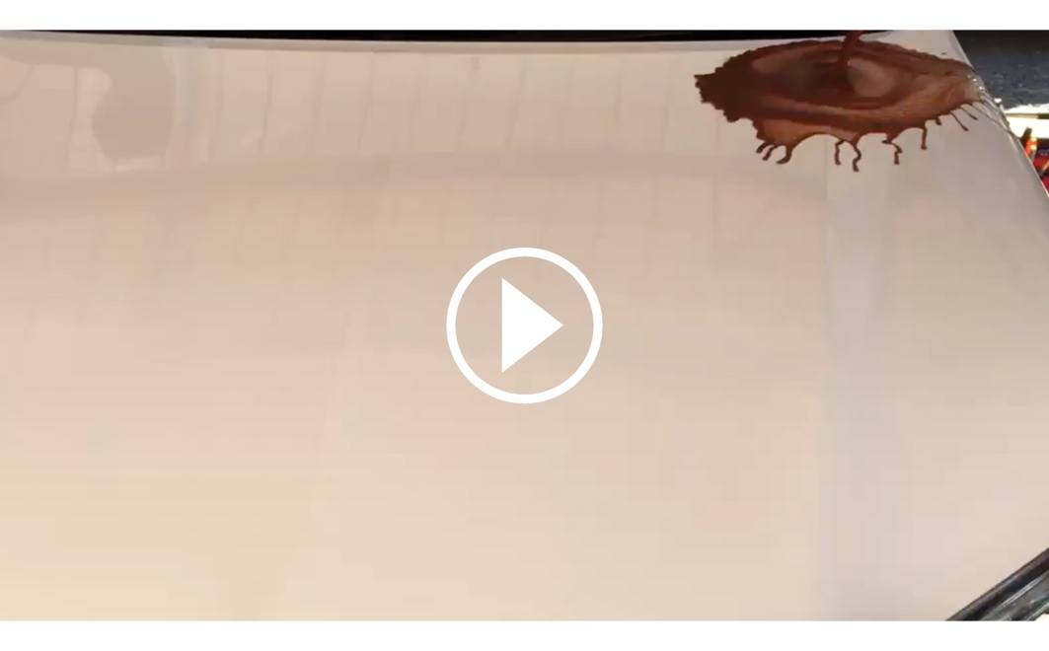
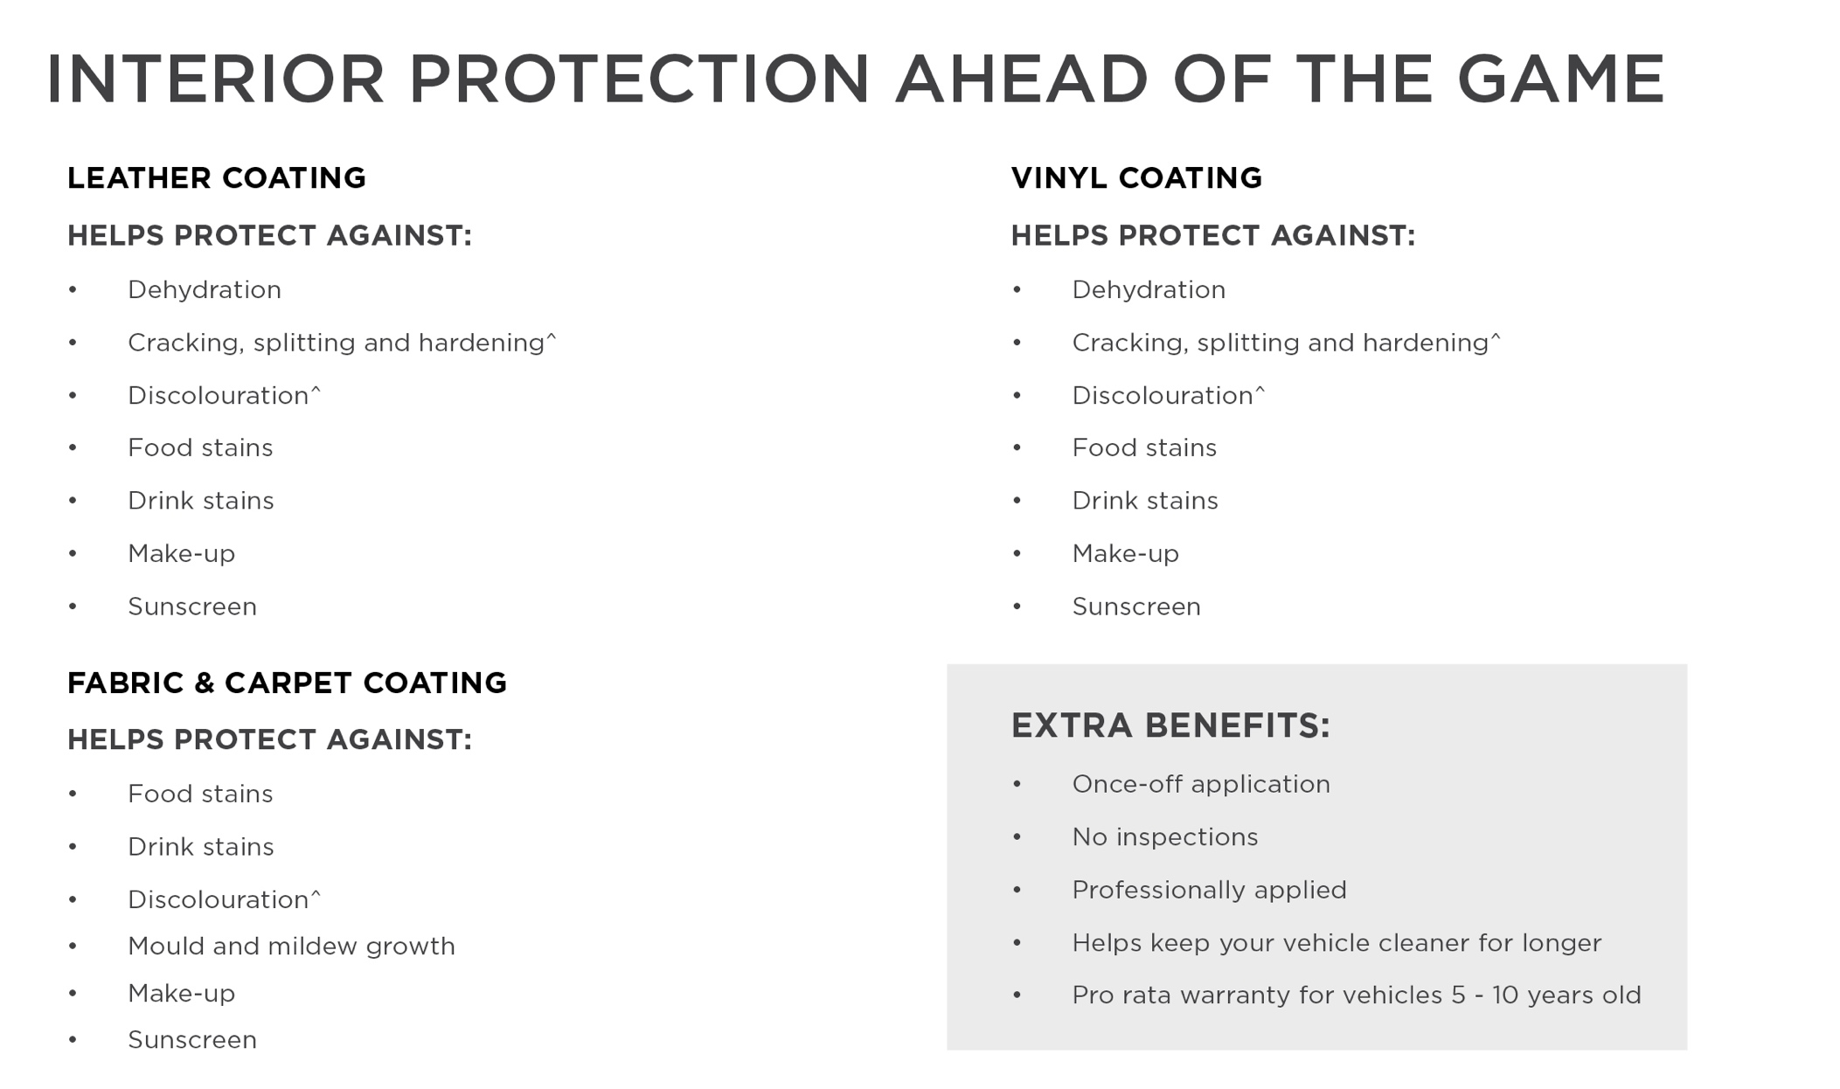
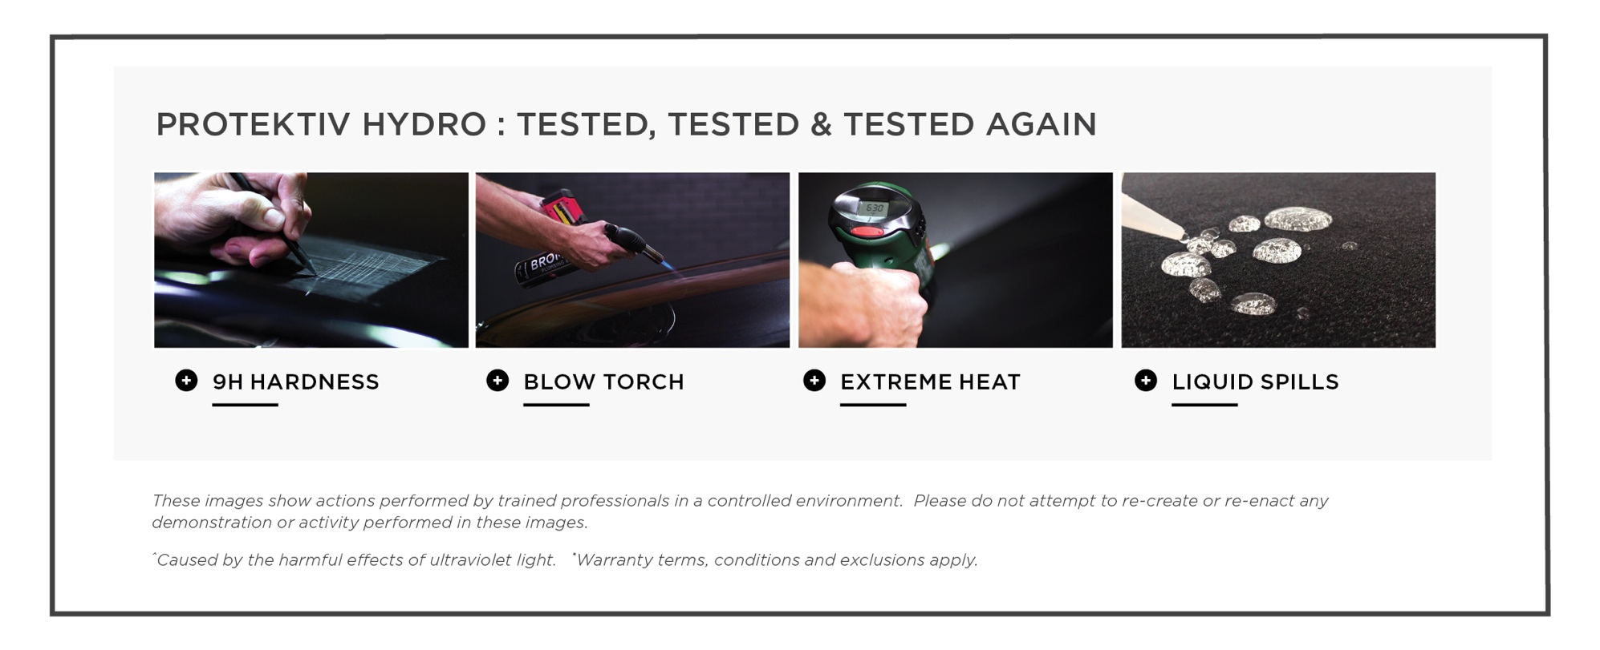
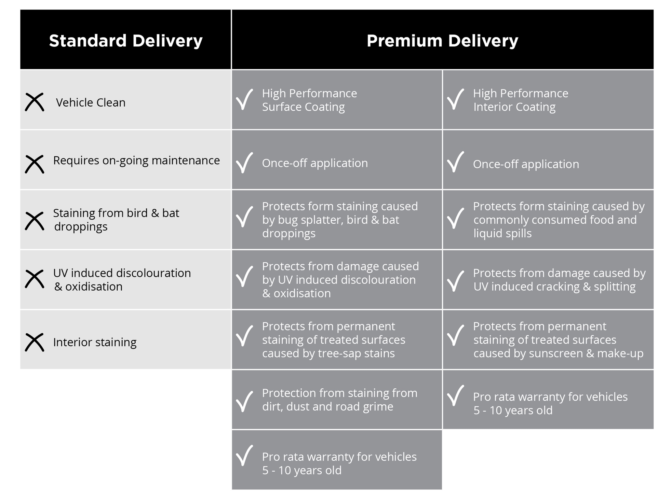
< Insert Dealership Name > knows that our < insert model of vehicle > customers like to take care of their new vehicles but free time in this day and age is honestly hard to come by. Our premium pre-delivery option gives you an ease of clean and a greater peace of mind by being covered with a national lifetime guarantee.

I will call you this afternoon for a brief 5-10 minute telephone conversation so you can let me know how you would like me to proceed in preparing your new vehicle for delivery.

