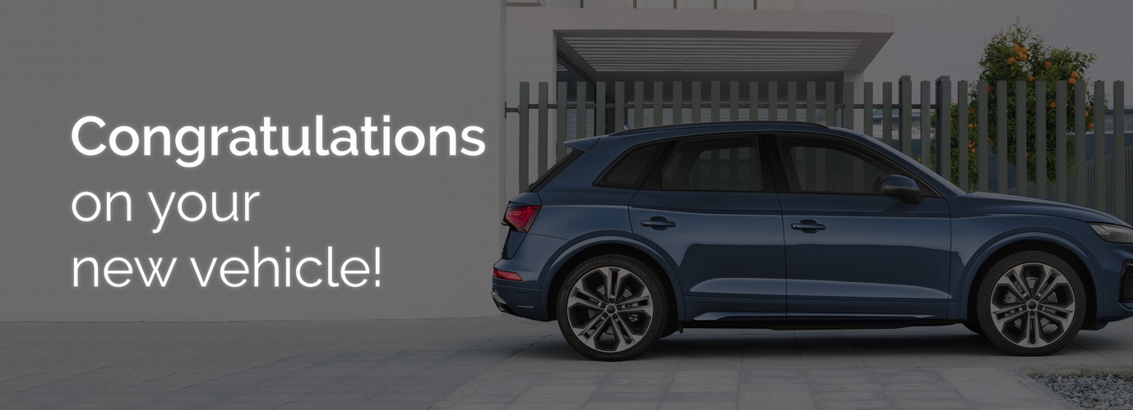
Good afternoon XXX,﻿
My name is <XXX> from <DEALERSHIP> and I will be preparing your new <VEHICLE BRAND> for delivery.
Please find below some important information regarding our Premium Delivery Package, which may be of interest before taking delivery of your new car.

The Protektiv HYDRO package will enhance the everyday appearance of your new vehicle while also providing a limited lifetime warranty* for painted and interior surfaces. ﻿As the most durable protective product on the market, Protektiv HYDRO is 4 times harder than quartz-based protectors. Made from a high performing formula combining Silicon Carbide (SiC) and Ceramic, your vehicle is protected with extreme durability, hardness and a permanent super gloss finish. ﻿﻿Designed to ensure your vehicle retains that showroom shine over the period of ownership, this once-off permanent finish.

Watch this short video to see the product in action. | 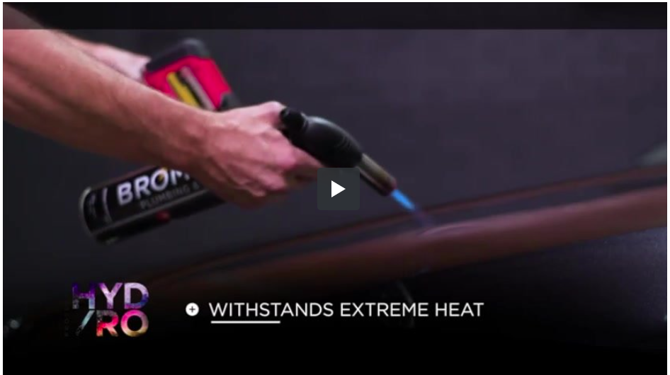
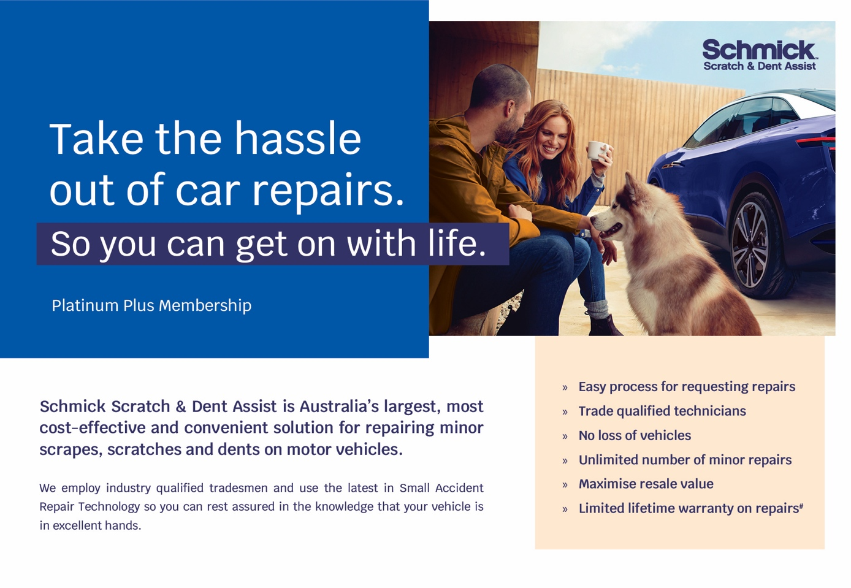
Have you considered a Schmick membership? Australia’s fastest growing, most cost-effective and convenient solution for repairing minor scrapes, scratches and dents on motor vehicles is Schmick Scratch & Dent Assist. Our National fleet of mobile repair vans can come to you at your home, or at your place of work#.
﻿Our industry-qualified tradesmen use the latest in Small Accident Repair Technology so you can be sure your vehicle is in excellent hands. ﻿Keeping your car looking as good as new, inside and out, is easy with Schmick Scratch & Dent Assist and the benefits and savings are significant.

Watch this short video on Schmick Scratch & Dent Assist! | 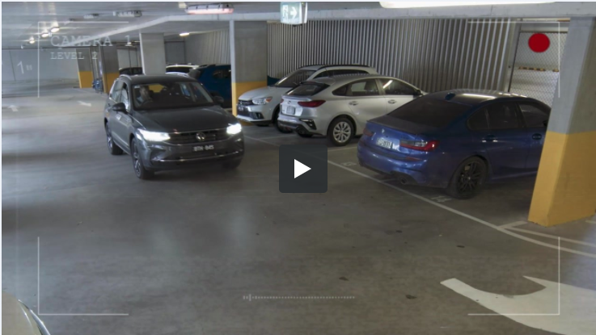
Currently your XXX has clear glass. We recommend you tint the full vehicle with Street Legal window film - the darkest window film for your vehicle, creating a look that will turn heads. |  | ﻿Benefits:  - ﻿﻿60% Glare rejection for maximum safety  - 99% UV rejection for maximum protection  - 60% Solar rejection for maximum comfort  - 35% Light transmitted for maximum privacy
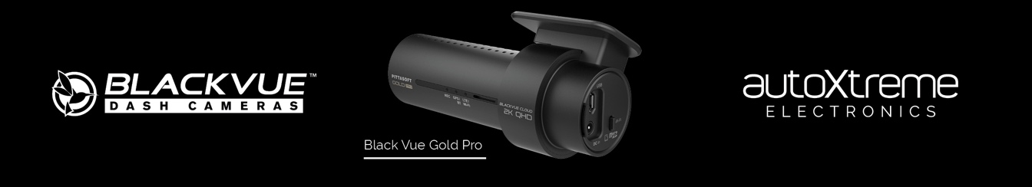
We want to ensure our customer’s have the latest information on driver safety and security - Introducing BlackVue Gold Pro with 2K quality quad HD recording, this dash camera is both first-class design impressive technology. |  | Benefits:  - ﻿﻿Full coverage - front & rear cameras ensure maximum coverage  - Instant replay - view the footage via the iOS or Android App  - 5 year nationwide warranty*^  *^T&C's apply.﻿
Delivery Package: | Individual Costings (RRP)
Protektiv HYDRO Exterior Surface Coating | Valued at $0,000
Protektiv HYDRO Leather Coating | Valued at $0,000
Protektiv HYDRO Fabric + Carpet Coating | Valued at $0,000
Protektiv HYDRO Vinyl Coating | Valued at $0,000
SCHMICK X- Year Membership | Valued at $0,000
Street Legal Window Film | Valued at $0,000
BlackVue Gold Pro Front & Rear Dash Camera | Valued at $0,000

Normally valued at $0000, this premium delivery package is on special for just $0000.
﻿﻿﻿We know that our customers like to take care of their new vehicles but free time is limited these days. This premium package gives you an ease of clean and a greater peace of mind by being covered with a national lifetime guarantee*.
I will call you this afternoon for a brief 5-10 minute chat so you can let me know how you would like me to proceed in preparing your new vehicle for delivery.
﻿﻿﻿﻿
#There are some restrictions on repair location.﻿ *Warranty term, conditions and exclusions apply.

Kind Regards,  [Name]  [Dealership Name] |  |  | [Address Details]  [Phone Number]  [Website address

