Hello [INSERT CUSTOMER FIRST NAME]

Congratulations on owning your new <VEHICLE NAME>!

My name is < INSERT NAME> from <DEALERSHIP>. I work closely with < INSERT SALESPERSON’S NAME> and help in the organisation and preparation of your new vehicle so you can take delivery shortly.

Given you’re close to receiving your new car, I’d like to introduce you to Schmick Scratch & Dent Assist. A Schmick membership can provide you with peace of mind knowing that unforeseen scratches, dents and scuffs caused by everyday travels can be repaired at your convenience – the national fleet of mobile panel repair vans can come to you at your home, or at your place of work.#
Pricing Guide  3 Year Membership - $825  4 Year Membership - $1100  5 Year Membership - $1375 | 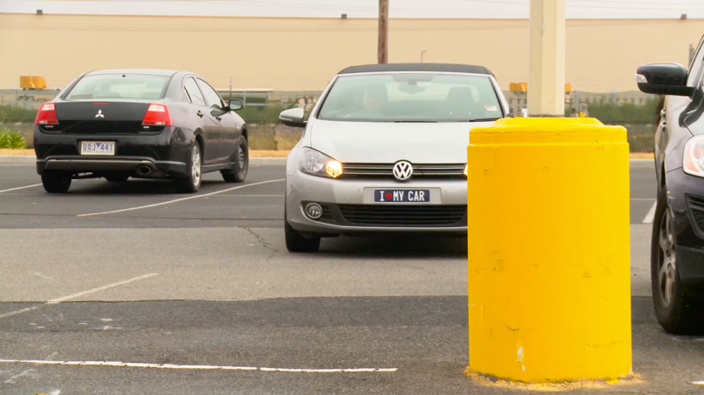
We want to ensure our customer’s have the latest information on driver safety and security - Introducing BlackVue Gold Pro with 2K quality quad HD recording, this dash camera is both first-class design impressive technology. | Benefits:  - ﻿﻿Full coverage - front & rear cameras ensure maximum coverage  - Instant replay - view the footage via the iOS or Android App  - 5 year nationwide warranty*^  *^T&C's apply.﻿
Delivery Package: | Individual Costings (RRP)
Protektiv HYDRO Exterior Surface Coating | Valued at $0,000
Protektiv HYDRO Leather Coating | Valued at $0,000
Protektiv HYDRO Fabric + Carpet Coating | Valued at $0,000
Protektiv HYDRO Vinyl Coating | Valued at $0,000
SCHMICK X- Year Membership | Valued at $0,000
Street Legal Window Film | Valued at $0,000
BlackVue Gold Pro Front & Rear Dash Camera | Valued at $0,000

Normally valued at $0000, this premium delivery package is on special for just $0000.
﻿﻿﻿We know that our customers like to take care of their new vehicles but free time is limited these days. This premium package gives you an ease of clean and a greater peace of mind by being covered with a national lifetime guarantee*.
I will call you this afternoon for a brief 5-10 minute chat so you can let me know how you would like me to proceed in preparing your new vehicle for delivery.
﻿﻿﻿﻿
#There are some restrictions on repair location.﻿ *Warranty term, conditions and exclusions apply.

Kind Regards,  [Name]  [Dealership Name] |  | [Address Details]  [Phone Number]  [Website address

