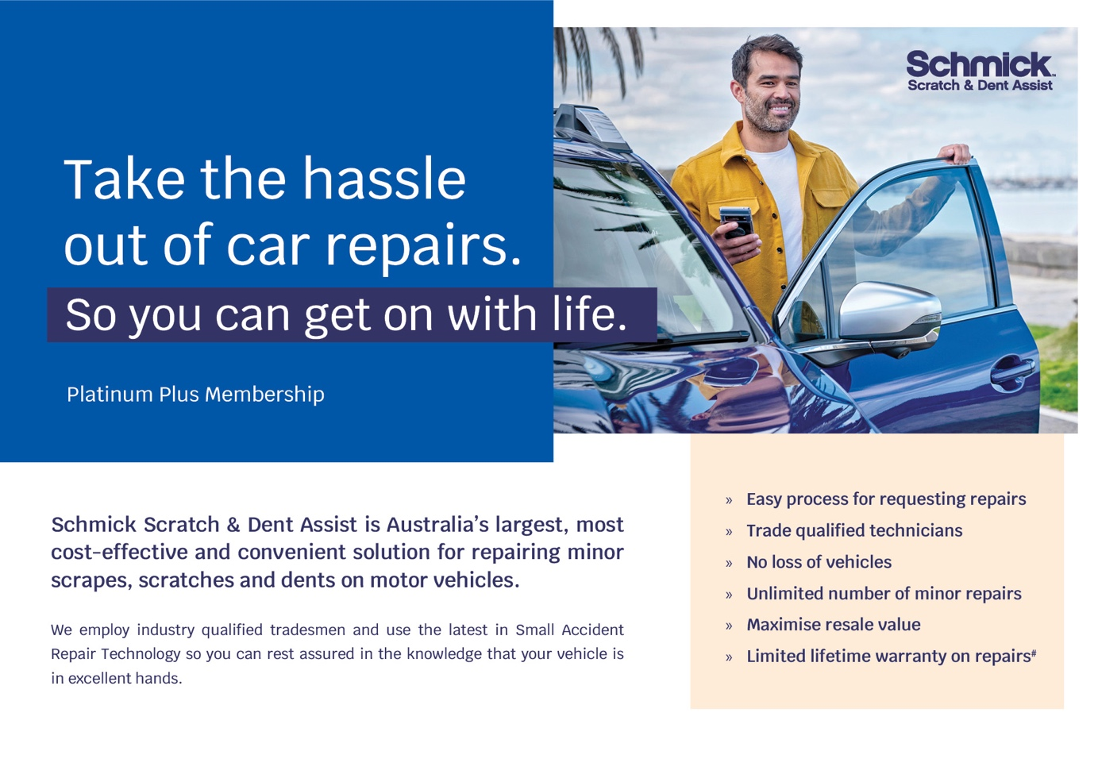
Hello [INSERT CUSTOMER FIRST NAME]

Congratulations on taking delivery of your New Car!!!

We hope you are enjoying the look and feel of your new car.

We just wanted to remind you that you are still eligible to invest in our Schmick Scratch & Dent Assist Membership Program. A Schmick membership can provide you with peace of mind knowing that unforeseen scratches and dents caused by everyday travels can be repaired at your home, at the fraction of the cost you would pay else were.

Have you been parking at the furthest car park at the busy shopping centres hoping to avoid minor damage to your new car? - Watch the video below to see more.
We know that our customers like to take care of their new vehicles but free time these days is limited. Schmick is a fast, convenient, and cost-effective way to help keep your car looking Schmick all year round.

And for a limited time, as a thank you for purchasing your new car with us, we are offering you $100 off any 3yr+ membership.

I will call you this afternoon for a brief 5-10 minute chat so you can let me know how you are going post-delivery.

