Hello [INSERT CUSTOMER FIRST NAME]

Congratulations on owning your new <VEHICLE NAME>!

My name is < INSERT NAME> from <DEALERSHIP>. I work closely with < INSERT SALESPERSON’S NAME> and help in the organisation and preparation of your new vehicle so you can take delivery shortly.

Given you’re close to receiving your new car, I’d like to introduce you to Schmick Scratch & Dent Assist. A Schmick membership can provide you with peace of mind knowing that unforeseen scratches, dents and scuffs caused by everyday travels can be repaired at your convenience – the national fleet of mobile panel repair vans can come to you at your home, or at your place of work.#
Pricing Guide  3 Year Membership - $825  4 Year Membership - $1100  5 Year Membership - $1375 | 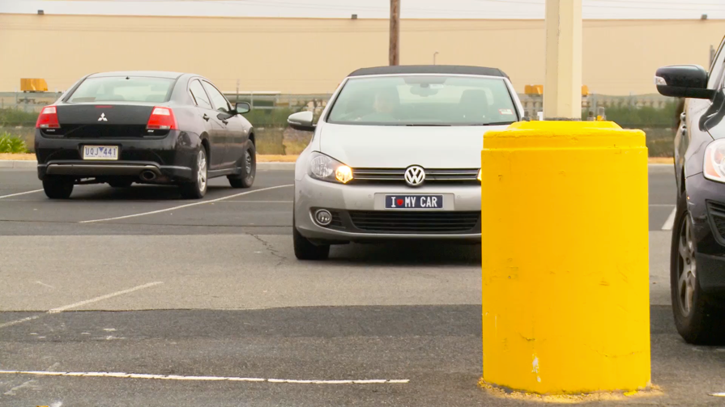
<INSERT DEALERSHIP NAME> knows that our < INSERT VEHICLE MAKE> customers like to take care of their new vehicles but free time these days is limited. Schmick is a fast, convenient and cost-effective way to help keep your car looking Schmick all year round.

I will call you this afternoon for a brief 5-10 minute telephone conversation so you can let me know how you would like me to proceed in preparing your new vehicle for delivery.

#There are some restrictions on repair location.

