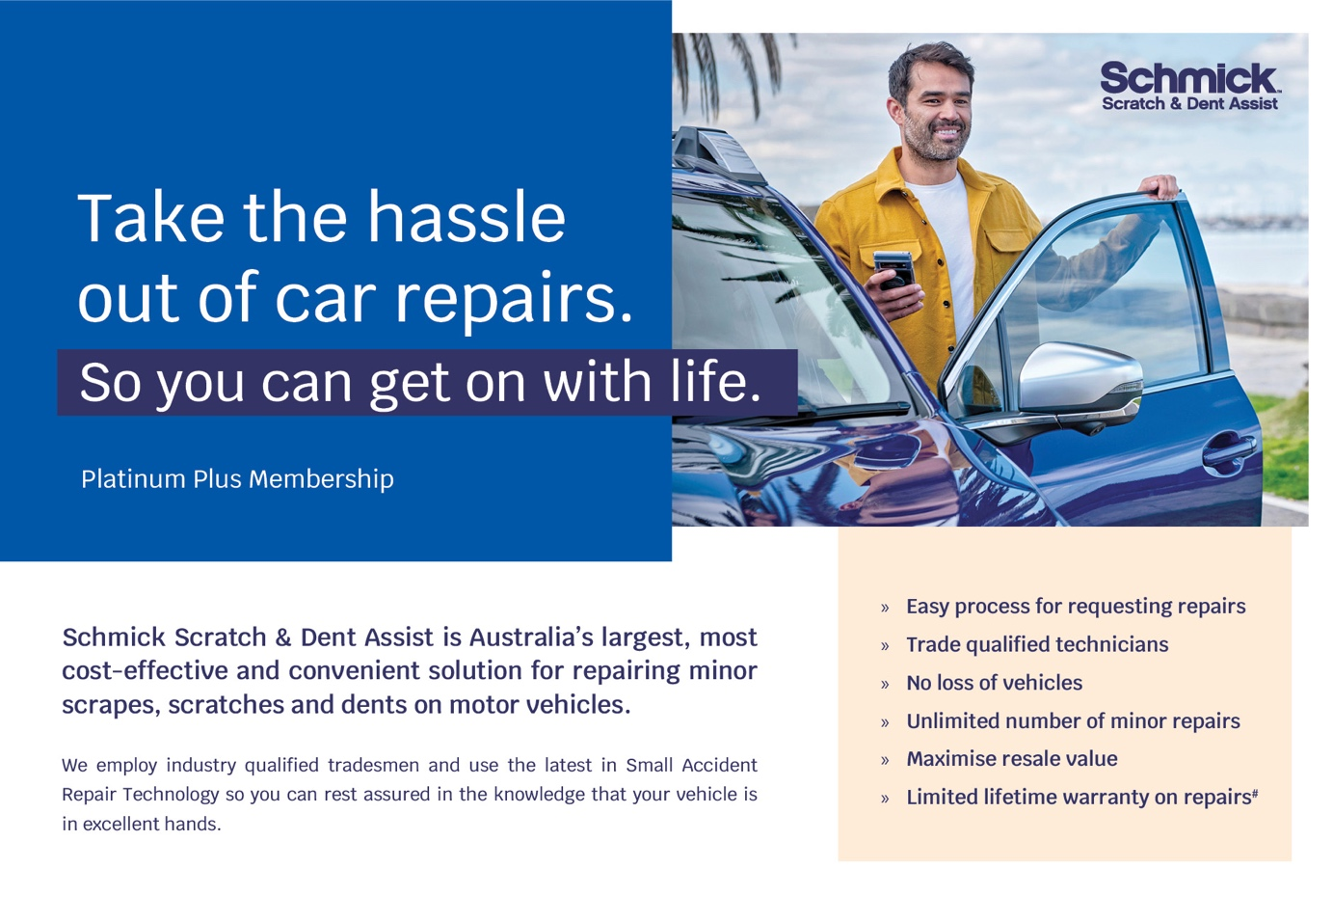
Hello [INSERT CUSTOMER FIRST NAME]

Congratulations on the Purchase of your Brand New Vehicle

Now that Your Car has Arrived in Australia, we are in the process of organising and preparing your new vehicle so you can take delivery shortly.

Given you’re close to receiving your new car, I’d like to tell you about an exciting new program we have introduced.

Schmick Scratch & Dent Assist is a membership that provides you with peace of mind knowing that unforeseen scratches, dents and scuffs caused by everyday travels can be repaired at your convenience – the national fleet of mobile panel repair vans can come to you at your home, or at your place of work.

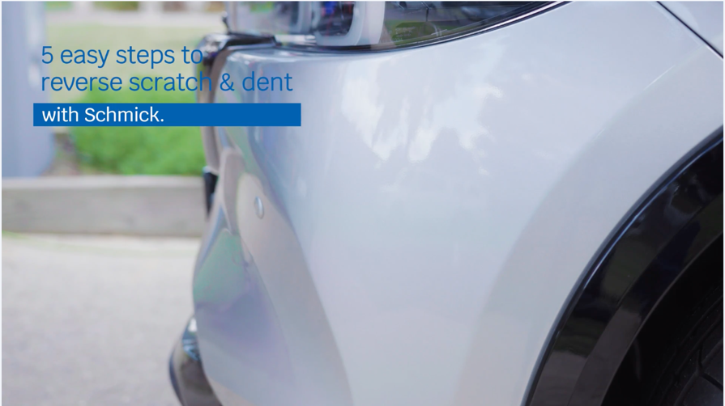

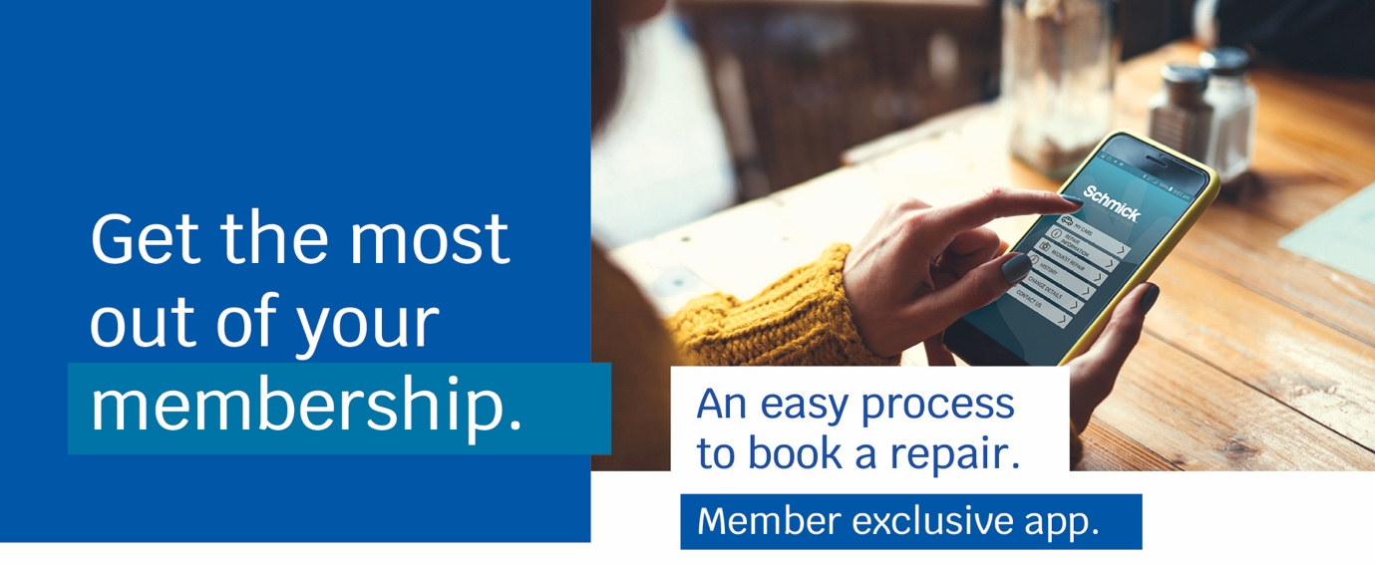
We know that our customers like to take care of their new vehicles but free time these days is limited and small damage often happens in busy car parks, without warning. Schmick is a fast, convenient, and cost-effective way to help keep your car looking Schmick all year round.

I will call you this afternoon for a brief 5-10 minute telephone conversation so you can let me know how you would like me to proceed in preparing your new vehicle for delivery.

