<Insert Dealer Logo>

Good afternoon XXX,﻿
My name is <XXX> from <DEALERSHIP> and I will be preparing your new <VEHICLE BRAND> for delivery.
Please find below some important information regarding our Premium Delivery Package, which may be of interest before taking delivery of your new car.

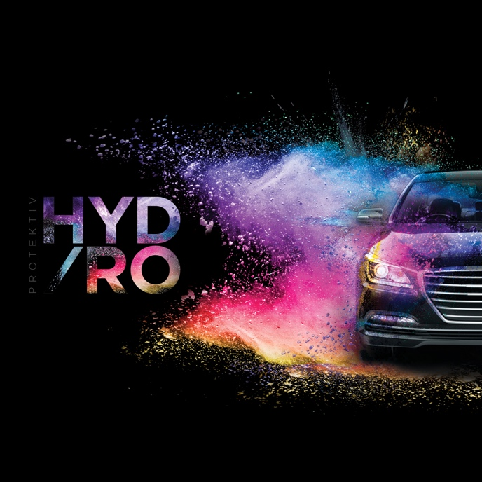 |  |  | The Protektiv HYDRO package will enhance the everyday appearance of your new vehicle while also providing a limited lifetime warranty* for painted and interior surfaces. ﻿As the most durable protective product on the market, Protektiv HYDRO is 4 times harder than quartz-based protectors. Made from a high performing formula combining Silicon Carbide (SiC) and Ceramic, your vehicle is protected with extreme durability, hardness and a permanent super gloss finish. ﻿﻿Designed to ensure your vehicle retains that showroom shine over the period of ownership, this once-off permanent finish.
Watch this short video to see the product in action. |  | 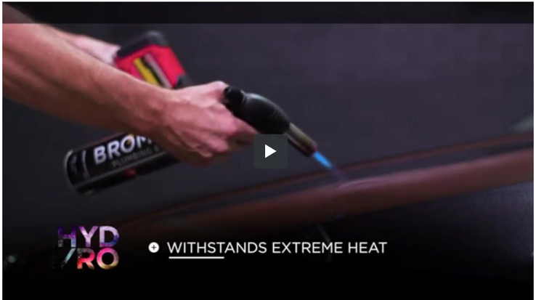
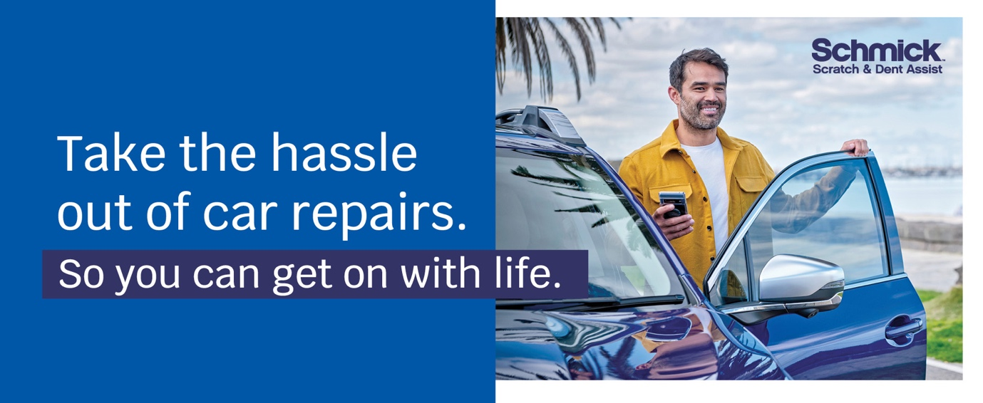
Have you considered a Schmick membership? Australia’s fastest growing, most cost-effective and convenient solution for repairing minor scrapes, scratches and dents on motor vehicles is Schmick Scratch & Dent Assist. Our National fleet of mobile repair vans can come to you at your home, or at your place of work#.
﻿Our industry-qualified tradesmen use the latest in Small Accident Repair Technology so you can be sure your vehicle is in excellent hands. ﻿Keeping your car looking as good as new, inside and out, is easy with Schmick Scratch & Dent Assist and the benefits and savings are significant.

Watch this short video on Schmick Scratch & Dent Assist! |  | 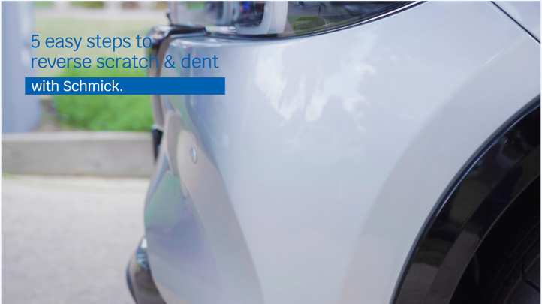
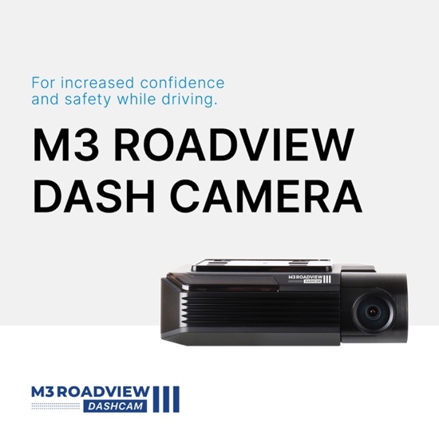 | Benefits:  - Premium video Quality thanks for SONY STARVIS image sensor  - Comes with Quad-HD 2K resolution  - GPS and WiFi enabled  - Includes a 64GB memory card  - Comes with a 5-year nationwide warranty*
Benefits:  - Top of the line recording quality with Ultra-HD 4K quality  - Supported by premium image sensors thanks to SONY STARVIS  - Includes a 64GB memory card  - GPS and WiFi enabled  - 5-year warranty* |  |  | 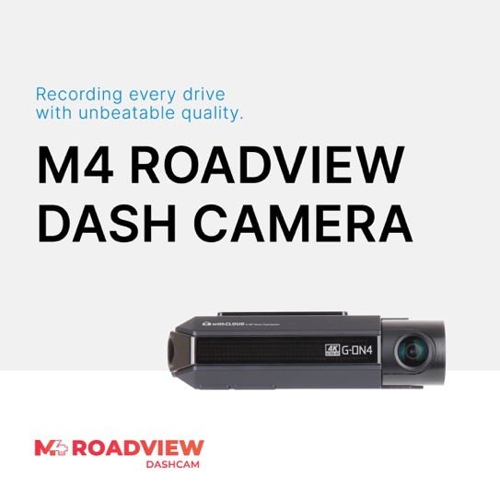
Delivery Package: | Individual Costings (RRP)
Protektiv HYDRO Exterior Surface Coating | Valued at $0,000
Protektiv HYDRO Leather Coating | Valued at $0,000
Protektiv HYDRO Fabric + Carpet Coating | Valued at $0,000
Protektiv HYDRO Vinyl Coating | Valued at $0,000
SCHMICK X- Year Membership | Valued at $0,000
M3 Front & Rear Dash Camera | Valued at $0,000
M4 Front & Rear Dash Camera | Valued at $0,000

Normally valued at $0000, this premium delivery package is on special for just $0000.
﻿﻿﻿We know that our customers like to take care of their new vehicles but free time is limited these days. This premium package gives you an ease of clean and a greater peace of mind by being covered with a national lifetime guarantee*.
I will call you this afternoon for a brief 5-10 minute chat so you can let me know how you would like me to proceed in preparing your new vehicle for delivery.
﻿﻿﻿﻿
#There are some restrictions on repair location.﻿ *Warranty term, conditions and exclusions apply.

Kind Regards,  [Name]  [Dealership Name] |  |  | [Address Details]  [Phone Number]  [Website address

