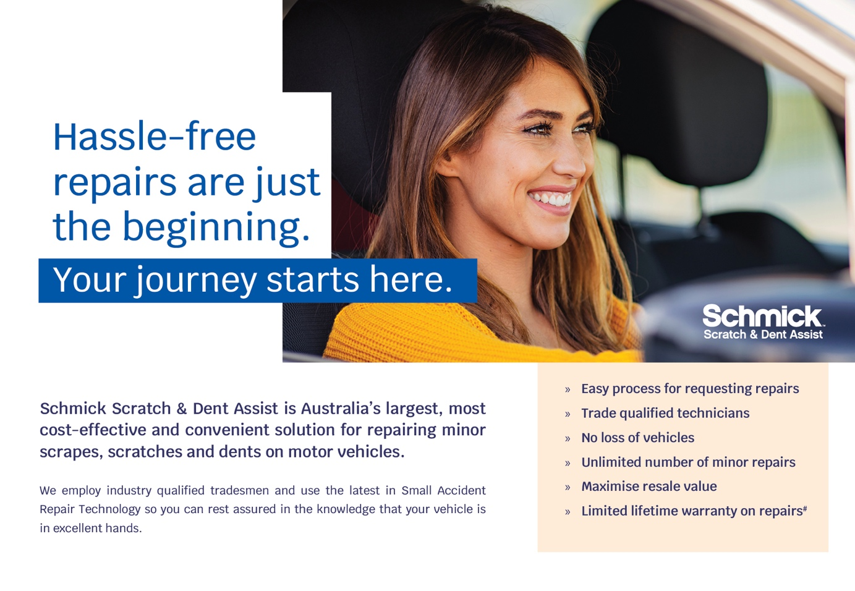
Hello [INSERT CUSTOMER FIRST NAME]

Congratulations on the delivery of your new <VEHICLE NAME>!

This email confirms that you have purchased a <amount of years> Schmick Membership. You will receive your official paperwork in the next <insert time frame>.
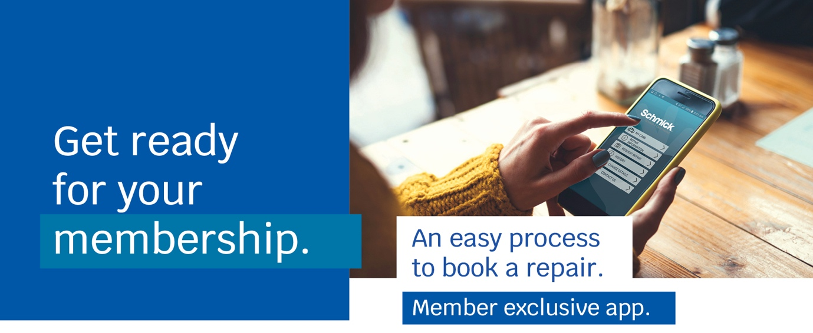
Get set up by downloading the Schmick app to your phone!

Apple Download |  | Android Download
Here’s a reminder of just how easy the repair process is! | 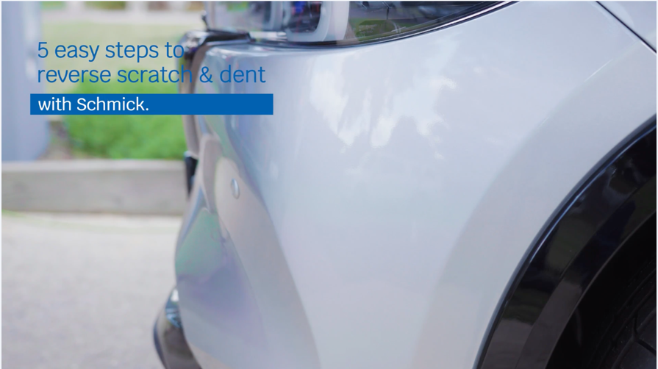
If you have any questions please feel free to respond to this email and I’ll do my best to assist.

Kind regards
<insert name>
<insert contact details>

