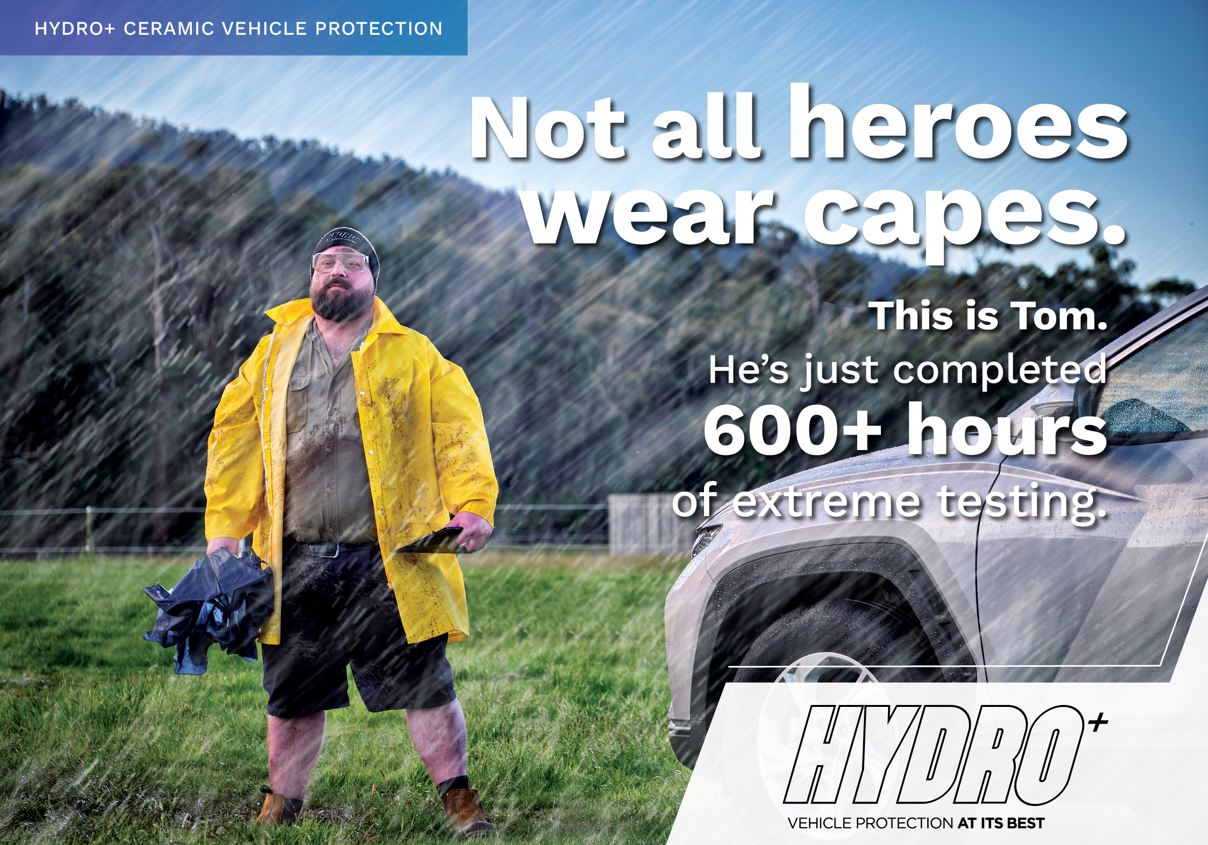
Good afternoon XXX,﻿

My name is <XXX> from <DEALERSHIP>. I’ll be preparing your new <VEHICLE/MODEL> for delivery. ﻿Please find below some important information regarding our Premium Delivery Package, which I hope you’ll consider before taking delivery of your new vehicle.

Vehicle protection guaranteed to outperform & outlast.

We’re committed to developing a high performing formula with outstanding resistance to the
harsh Australian climate.

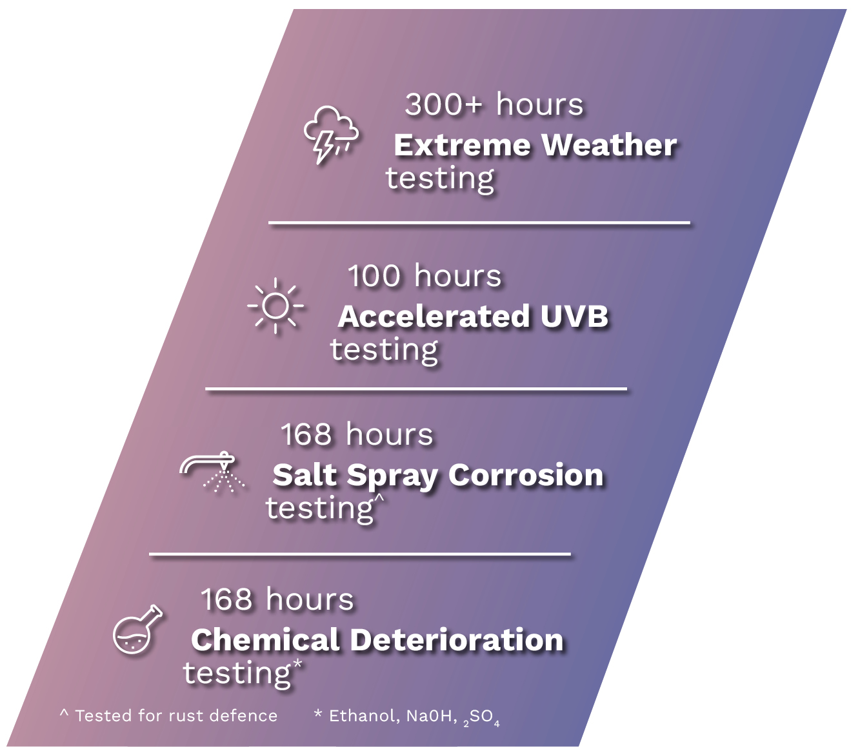 | The HYDRO+ new ceramic-carbide formula provides a smoother touch, a greater level of gloss and the highest performance for your vehicle.  Helps protect against weather induced oxidization, fading and discolouration of paintwork.  Helps prevent damage caused by bird and bat droppings, tree sap and fallen leaves, bug splatter on leading edges, permanent water marks and discolouration damage caused by bore water, rail dust and sunscreen residue.  Effortlessly cleans away dirt & grime with water beading and contaminants simply sliding off the paintwork.  No waxing or polishing required keeping vehicle exterior maintenance at a minimum.  Covered by a limited lifetime warranty*
HYDRO+ surface coating is formulated using graphene, an extremely pure material, thanks to its simple structure based on tight, consistent, atomic bonding.
﻿﻿
HYDRO+ interior product range includes newly formulated protective coatings for leather, vinyl, plastics and fabric & carpet. ﻿These interior surface coatings ensure maximum stain resistance, protection for the damaging effects of UV and delivers an extremely durable finish. Backed by a limited lifetime warranty.*
Watch this short video to see the product in action.  HYDRO+ delivers exceptional levels of hardness which translates to increased resistance to the elements and UV stability offering greater defence against fading and oxidation of clear and base coats. This newly formulated surface coating bonds deeper into the vehicle’s paintwork, is noticeably smoother to the touch and optically brighter. Backed by a limited lifetime warranty.* |  | 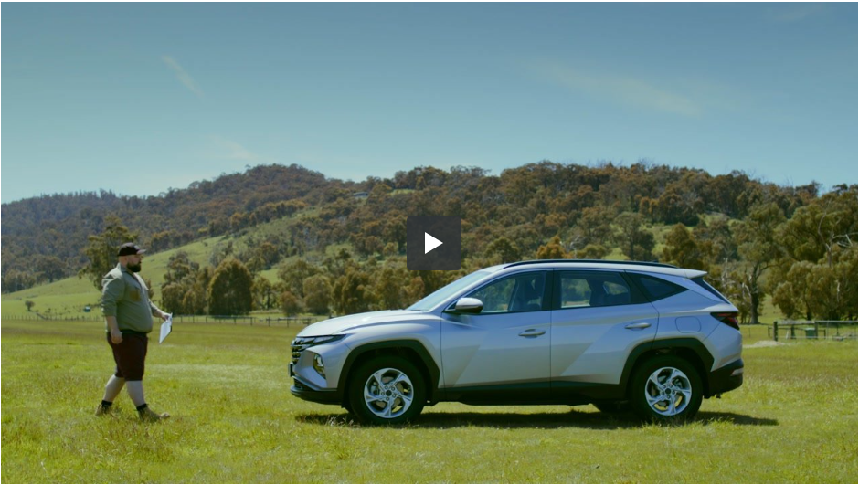
THIS FULL PACKAGE INCLUDES:  HYDRO+ Exterior Surface Coating  HYDRO+ Leather Coating  HYDRO+ Fabric + Carpet Coating  HYDRO+ Vinyl Coating |  |  | INDIVIDUAL COSTINGS:  Valued at $0000  Valued at $0000  Valued at $0000  Valued at $0000
We know that our customers like to take care of their new vehicles but free time in this day and age is honestly hard to come by. Our premium pre-delivery option gives you an ease of clean and a greater peace of mind by being covered with a national lifetime guarantee*.

Please advise how you would like me to proceed in preparing your vehicle for delivery.

Kind Regards,
[Name]
[Dealership Name]
[Address Details]
[Phone Number]
[Website address]

* Warranty terms, conditions & exclusions apply.

