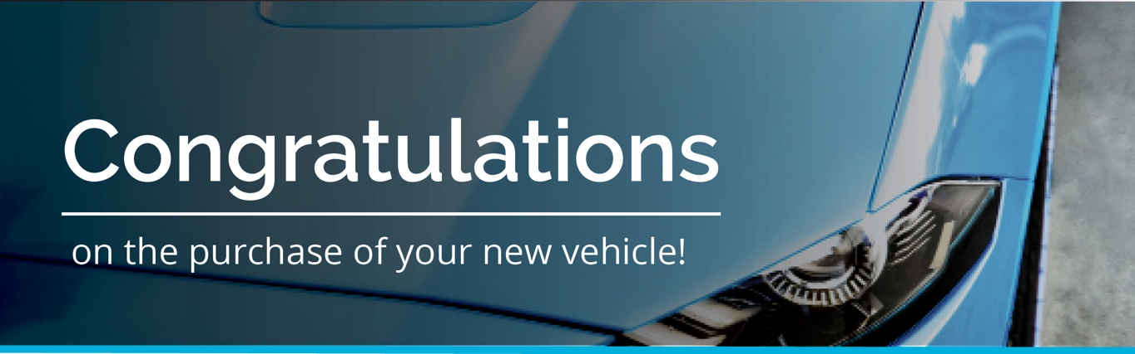
Good afternoon XXX,﻿
My name is <XXX> from <DEALERSHIP>. I’ll be preparing your new <VEHICLE/MODEL> for delivery.
Please find below some important information regarding our Premium Delivery Package, which I hope you’ll consider before taking delivery of your new vehicle.

NEW FORMULA SURFACE COATING WITH GRAPHENE. NOW TOUGHER THAN EVER!
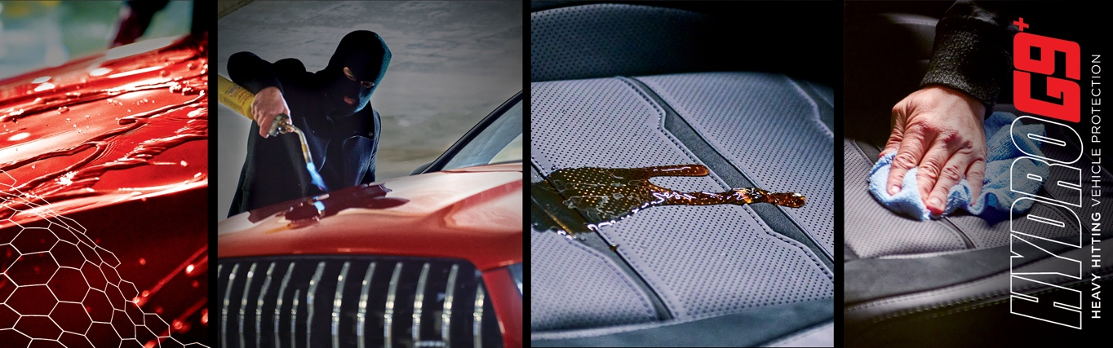
Introducing HYDRO^{G9+}. This new formula ceramic surface coating delivers exceptional levels of hardness which simply means increased durability to the elements.

- Newly engineered ceramic surface coating bonds deeper into the vehicle’s paintwork for added protection, gloss and shine.
- Your vehicle’s paintwork will be noticeably smoother to the touch and optically brighter.
- Delivers UV stability and greater protection against fading and oxidation of clear and base coats.
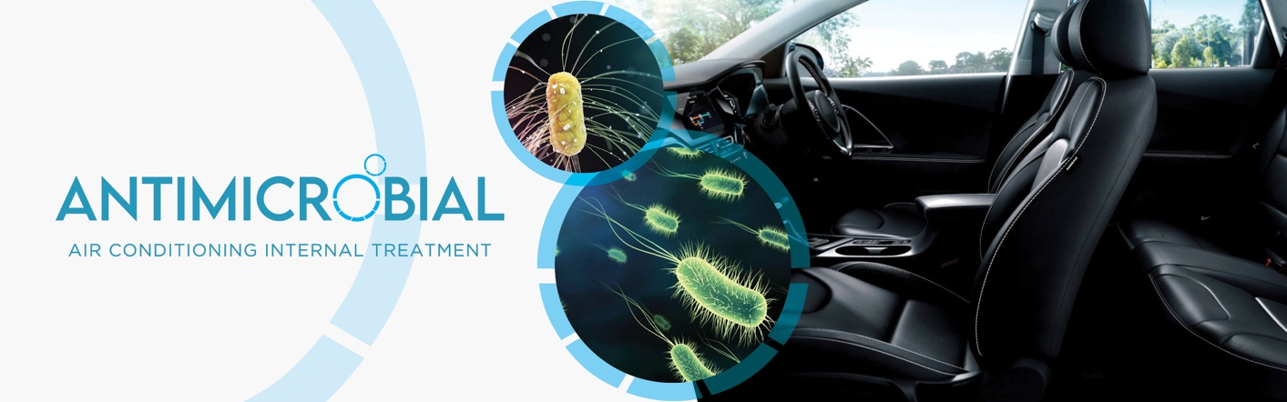
- Plus you have the option of our HYDRO^{G9+} interior protection range; newly formulated protective coatings for leather, vinyl, plastics, fabric, and carpet ensuring maximum stain resistance and lasting protection from the damaging effects of UV.

Introducing Antimicrobial. A must if you’re looking to an interior sanitisation application before vehicle delivery. One treatment will help provide you an odour-free, germ-free, and allergen-free vehicle, giving you peace of mind and a healthier environment.

- Cleans, sanitises, and disinfects your vehicle’s air conditioning system, removing odours as well as bacteria, mould and micro-organisms from your car’s interior.
- Antimicrobial provides a long-lasting barrier against the re-generation of bacteria plus provides a deodorising, fresh fragrance.

Watch this short video for more information on HYDRO^{G9+} and Antimicrobial.

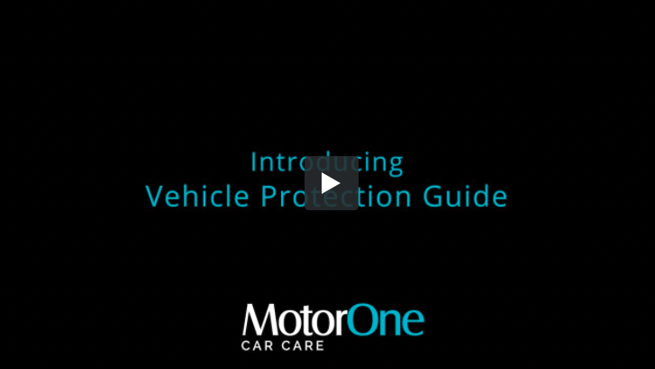
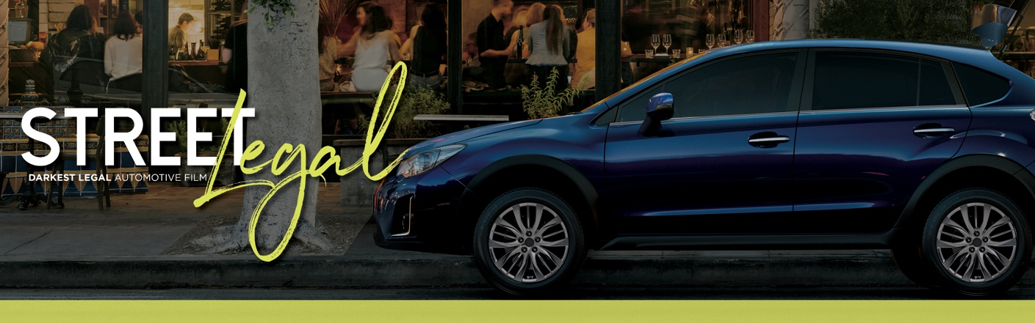
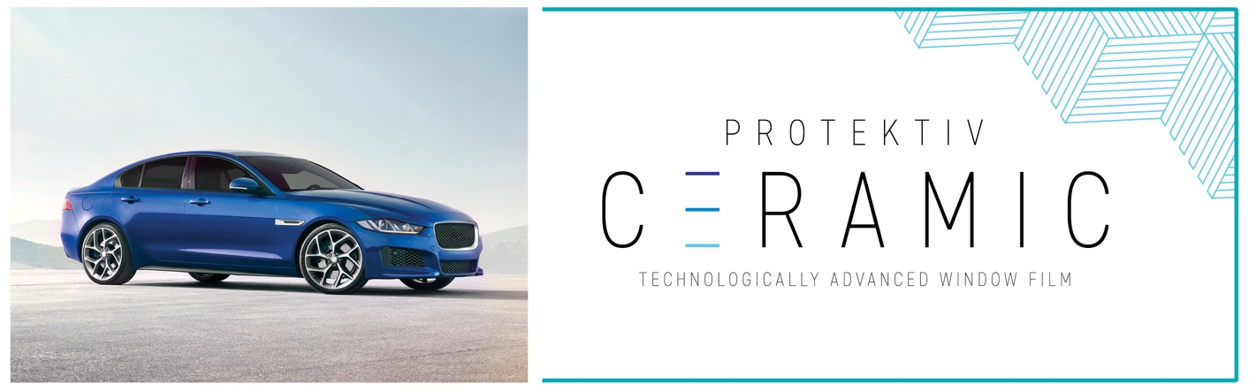
INTRODUCING OUR BEST-OF-BREED WINDOW TINT{S}
Protektiv Ceramic: This is a great looking window tint! Engineered using nanotechnology to create a ceramic composition so small it’s invisible to the naked eye.
- Protektiv Ceramic is 100% colour stable and delivers amazing optical clarity.
- It’s 100% metal free to avoid causing electromagnetic interference (EMI) with electronic devices such as GPS, car radios and mobile phones.

Street Legal. Darkest Legal Tint. This film delivers both performance and great looks.
- Provides all the heat, glare, comfort and UV protection you’d expect from a top performing window film.
- Meets all state legal requirements and regulations for visible light transmittance.
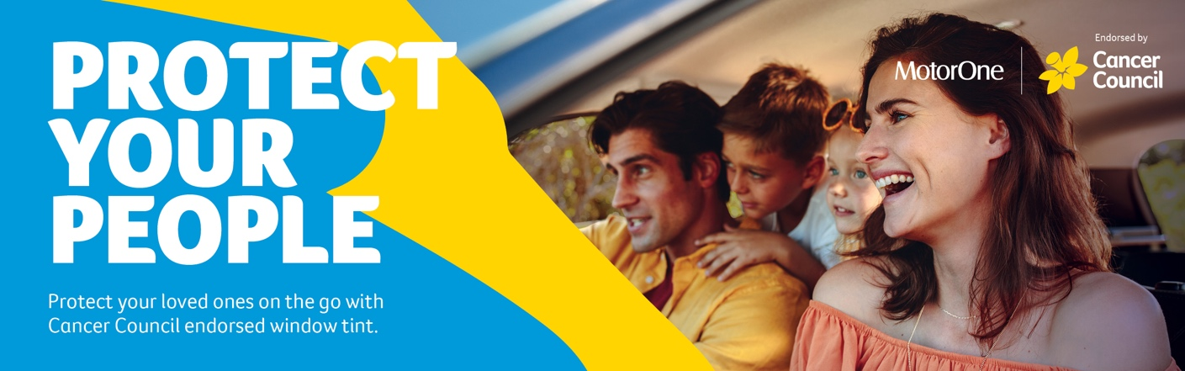
Protect your people. Protect your loved ones on the go with Cancer Council endorsed window tint.
Join over 1 million Australians who have contributed to the $6 million already donated to Cancer Council through their purchases of endorsed window tints. Contributions go towards cancer research and associated services.
Available for purchase:
- Dark night: darkest legal protection
- UV Clear: Invisible protection with the tinted window look.

All our Premium Package products can be applied before you take delivery of your new vehicle, and all come with a peace of mind national limited lifetime guarantee*.
Delivery Package: | Individual Costings (RRP)
HYDRO^{G9+} Exterior Surface Coating | Valued at $0,000
HYDRO^{G9+} Interior Surface Coating | Valued at $0,000
Antimicrobial Air Conditioning Internal Treatment | Valued at $0,000
Protektiv Ceramic Window Film | Valued at $0,000
Street Legal Window Film | Valued at $0,000
Cancer Council Tint: Dark Night | Valued at $0,000

Normally valued at $0000, this Premium Delivery Package is on special for just $0000.
﻿﻿I’ll call you this afternoon for a brief 5–10-minute chat so you can let me know how you would like me to proceed with the preparation of your new vehicle before delivery.
﻿﻿﻿
*Warranty term, conditions and exclusions apply.

Kind Regards,  [Name]  [Dealership Name] | [Address Details]  [Phone Number]  [Website address

