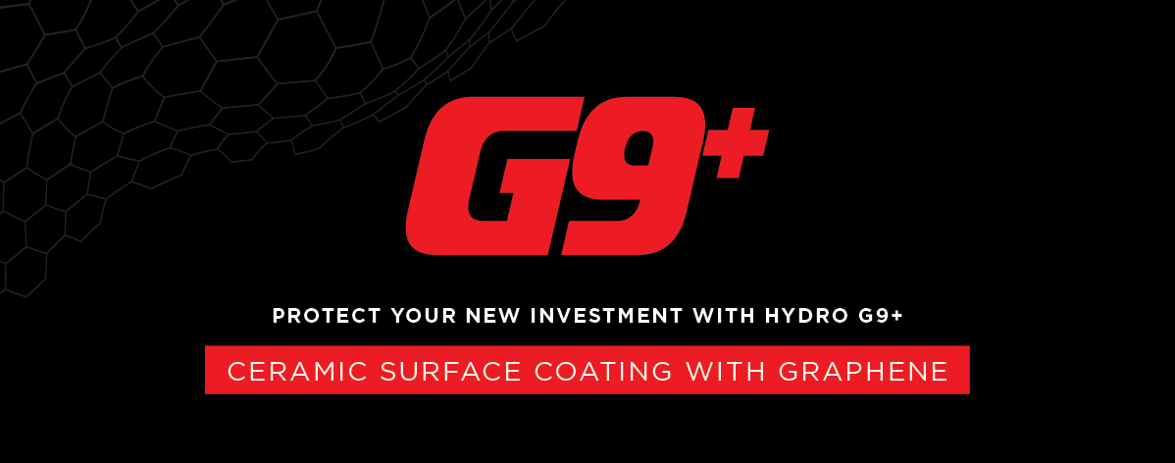
Dear ___

My name is <XXX> from <DEALERSHIP>. I’ll be preparing your new <VEHICLE/MODEL> for delivery. As I begin this process, I wanted to introduce you to our popular surface coating HYDRO G9+, designed to prolong your showroom shine and protect your brand new investment.

Prefer to discuss on the phone? Call me on XXXX XXX XXX.
WHAT IS HYDRO G9+?

HYDRO G9+ is the latest formula in ceramic surface protection designed to protect your vehicles paintwork from weathering, oxidisation and damaging environmental contaminants. This new formula contains Graphene which brings exceptional levels of hardness and strength, protecting your car better than ever before.

HYDRO G9+ also provides unsurpassed durability and stain resistance on the interiors.
MAINTAINS SHOWROOM SHINE | REDUCES THE NEED FOR FREQUENT WASHING | ONCE-OFF APPLICATION |  | BACKED BY A NATIONWIDE LIMITED LIFETIME WARRANTY*
Don’t just take my word for it…read a real review!

“Had opted for HYDRO G9+ on my metallic white car and so far, it is a fantastic product.

You can actually feel an extra protection layer on the paint itself and it’s easy to clean. Low maintenance.

Can only recommend, no faults to point out. Feels like good quality. Worth investing to protect your car.”

James C.

Ready to protect your car?
THIS FULL PACKAGE INCLUDES:  HYDRO G9+ Exterior Surface Coating  HYDRO G9+ Leather Coating  HYDRO G9+ Fabric + Carpet Coating  HYDRO G9+ Vinyl Coating  PREMIUM Darkest Legal Window Film |  |  | INDIVIDUAL COSTINGS:  Valued at $0000  Valued at $0000  Valued at $0000  Valued at $0000  Valued at $0000
Please advise how you would like me to proceed in preparing your vehicle for delivery.

Kind Regards,
[Name]
[Dealership Name]
[Address Details]
[Phone Number]
[Website address]

*Warranty terms and conditions apply.

