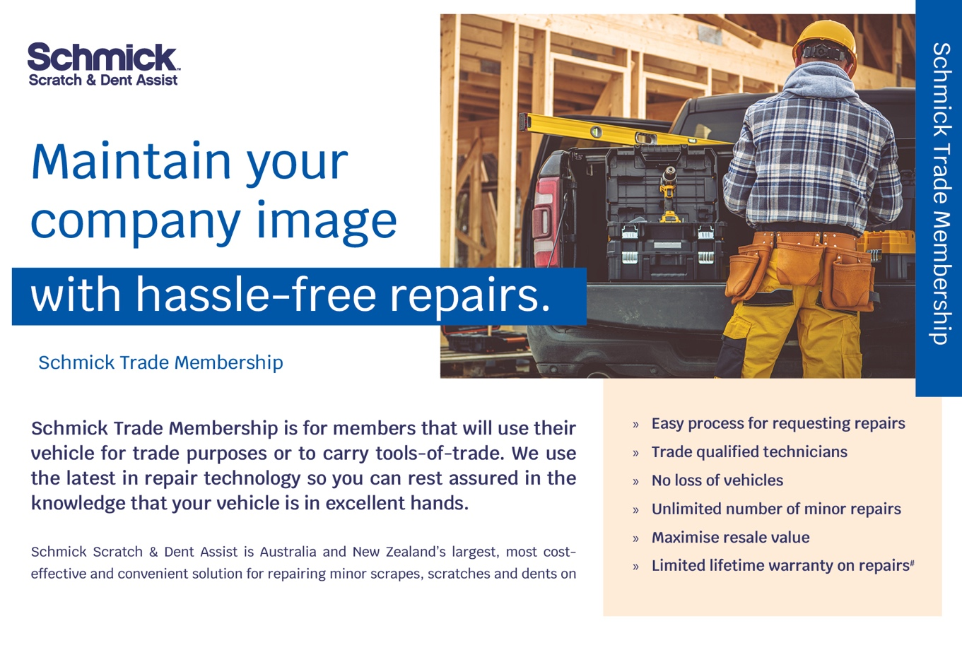
Hello [INSERT CUSTOMER FIRST NAME]

Congratulations on taking delivery of your New Vehicle!!!

As a business we understand that company image is important. As such we are excited to offer you our Schmick Scratch & Dent Assist Trade Membership Program, exclusively offered for vehicles being used for commercial/trade use. It’s a cost-effective way to maintain your company vehicle, by repairing all those small scratches and dents that can look unsightly when visiting your customers’, or when handing back the vehicle at end of lease or for Guaranteed Future Value

As a valued customer, you are eligible for our launch special on a 3year membership. I have attached a brochure for your perusal.

Watch our video below to see how easy it is to get a repair made by Schmick!
Please reply YES if you would like some more information.

I will touch base with you over the next few days to answer any questions you may have.

