<insert dealre logo>

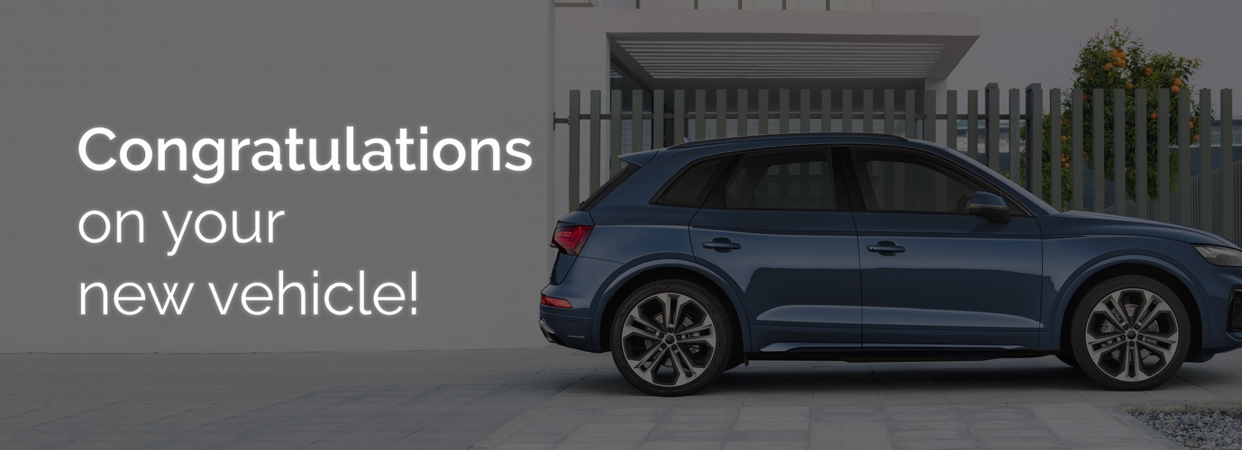
Good afternoon XXX,﻿
My name is <XXX> from <DEALERSHIP> and I will be preparing your new <VEHICLE BRAND> for delivery.
Please find below some exciting options regarding our Premium Delivery Package, which may be of interest before taking delivery of your new car.

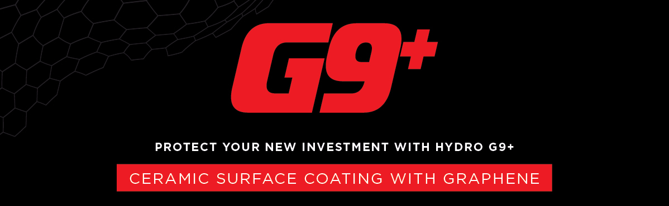
The HYDRO G9+ package will enhance the everyday appearance of your new vehicle while also providing a limited lifetime warranty* for painted and interior surfaces. ﻿As the most durable protective product on the market, HYDRO G9+ has many benefits:

MAINTAINS SHOWROOM SHINE | REDUCES THE NEED FOR FREQUENT WASHING | ONCE-OFF APPLICATION | BACKED BY A NATIONWIDE LIMITED LIFETIME WARRANTY*

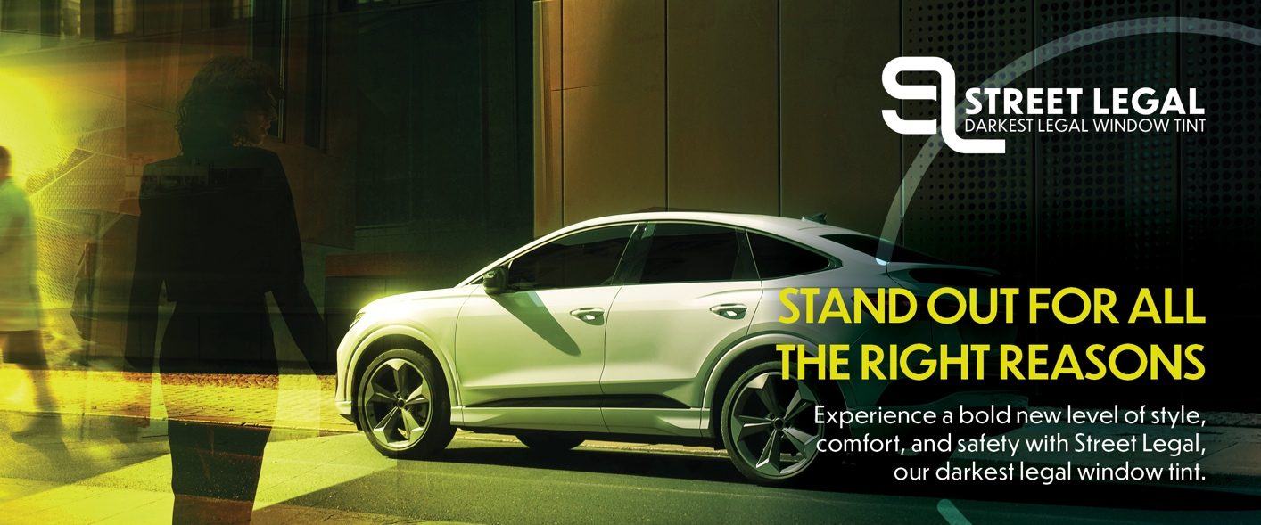

Currently your XXX has clear glass. We recommend you tint the full vehicle with Street Legal window film - the darkest window film for your vehicle, creating a look that will turn heads. | ﻿Benefits:  - ﻿﻿60% Glare rejection for maximum safety  - 99% UV rejection for maximum protection  - 60% Solar rejection for maximum comfort  - 35% Light transmitted for maximum privacy
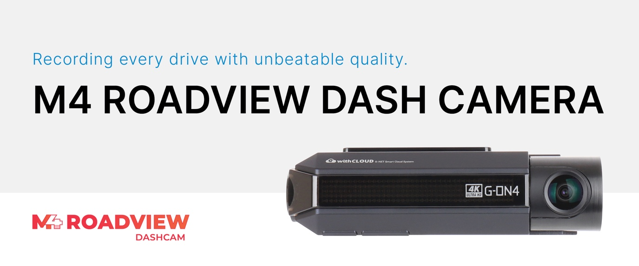
The M4 Roadview is an industry leading dash camera owing to its 4K quality and Sony Starvis Sensor. It’s the perfect companion on the road, recording 24/7 in all lighting conditions. | Benefits:  - Top of the line recording quality with Ultra-HD 4K quality  - Front and Rear recorging  - Supported by premium image sensors thanks to SONY STARVIS  - Includes a 64GB memory card  - GPS and WiFi enabled  - 5-year warranty*  *^T&C's apply.﻿
Delivery Package: | Individual Costings (RRP)
HYDRO G9+ Exterior Surface Coating | Valued at $0,000
HYDRO G9+ Leather Coating | Valued at $0,000
HYDRO G9+ Fabric + Carpet Coating | Valued at $0,000
HYDRO G9+ Vinyl Coating | Valued at $0,000
Street Legal Window Film | Valued at $0,000
M4 Roadview Front & Rear Dash Camera | Valued at $0,000

Normally valued at $0000, this premium delivery package is on special for just $0000.
﻿﻿﻿We know that our customers like to take care of their new vehicles but free time is limited these days. This premium package gives you an ease of clean and a greater peace of mind by being covered with a national lifetime guarantee*.
I will call you this afternoon for a brief 5-10 minute chat so you can let me know how you would like me to proceed in preparing your new vehicle for delivery.
﻿﻿﻿﻿
#There are some restrictions on repair location.﻿ *Warranty term, conditions and exclusions apply.

Kind Regards,  [Name]  [Dealership Name] |  | [Address Details]  [Phone Number]  [Website address

