<Insert Dealer Logo>

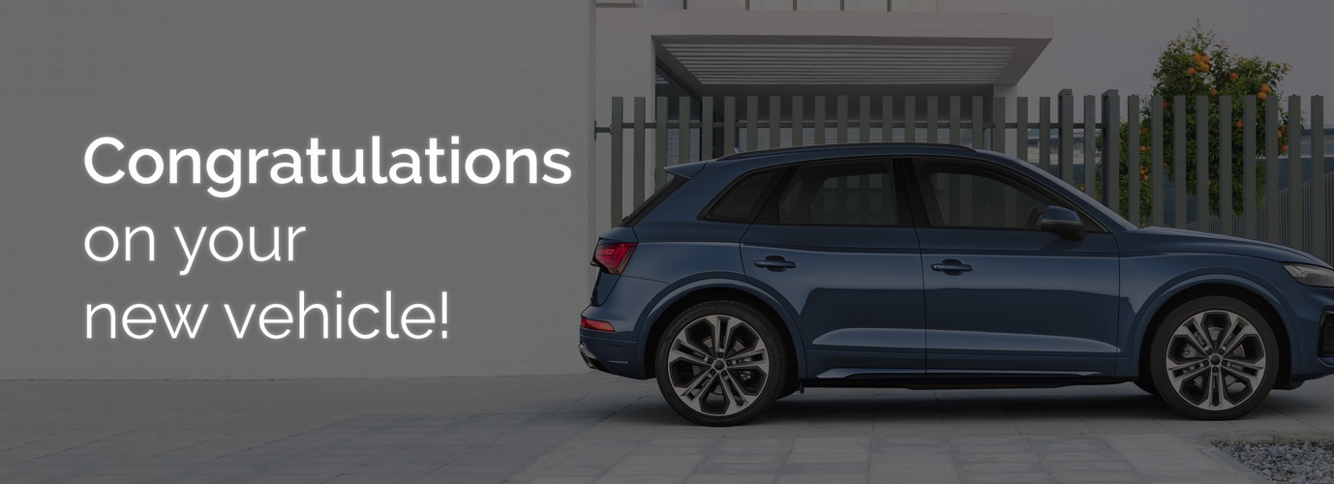
Good afternoon XXX,﻿
My name is <XXX> from <DEALERSHIP> and I will be preparing your new <VEHICLE BRAND> for delivery.
Please find below some important information regarding our Premium Delivery Package, which may be of interest before taking delivery of your new car.

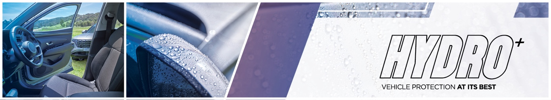
The HYDRO+ package will enhance the everyday appearance of your new vehicle while also providing a limited lifetime warranty* for painted and interior surfaces. ﻿As the most durable protective product on the market, HYDRO+ has many benefits:
- Helps protects against contaminants such as bird droppings, tree sap, sunscreen and more,
- Has had over 600 hours of product testing,
- Made from a high performing formula combining Silicon Carbide (SiC) and Ceramic,
- ﻿﻿Retains that showroom shine over the period of ownership,
- Backed by a lifetime warranty.

Watch this short video to see the product in action. | 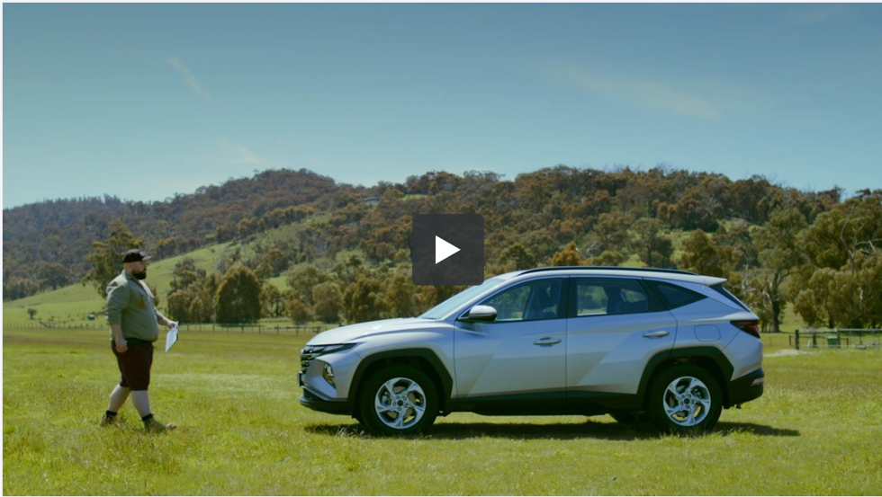
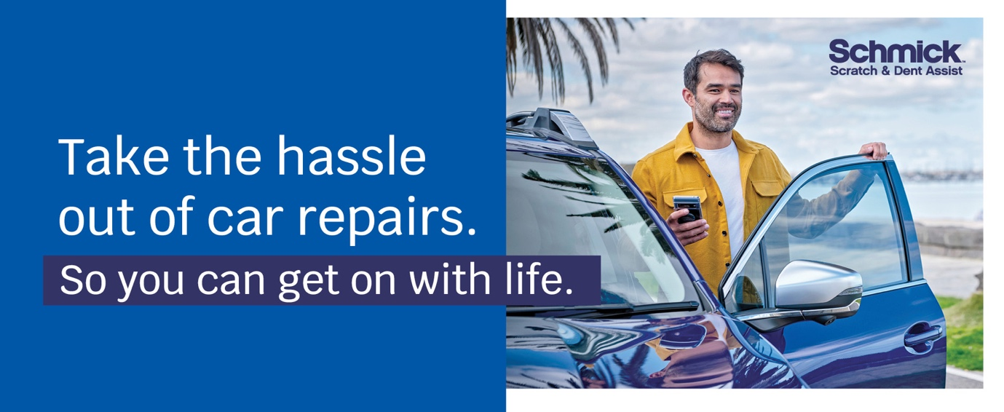
Have you considered a Schmick membership? Australia’s fastest growing, most cost-effective and convenient solution for repairing minor scrapes, scratches and dents on motor vehicles is Schmick Scratch & Dent Assist. Our National fleet of mobile repair vans can come to you at your home, or at your place of work#.
﻿Our industry-qualified tradesmen use the latest in Small Accident Repair Technology so you can be sure your vehicle is in excellent hands. ﻿Keeping your car looking as good as new, inside and out, is easy with Schmick Scratch & Dent Assist and the benefits and savings are significant.

Watch this short video on Schmick Scratch & Dent Assist! | 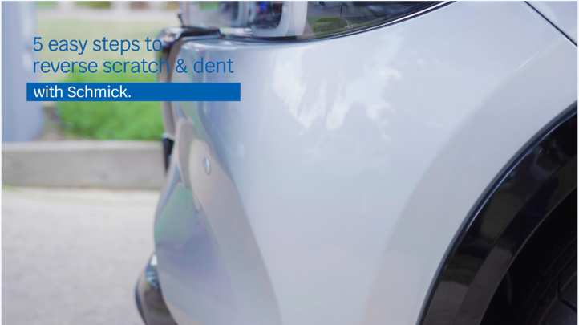
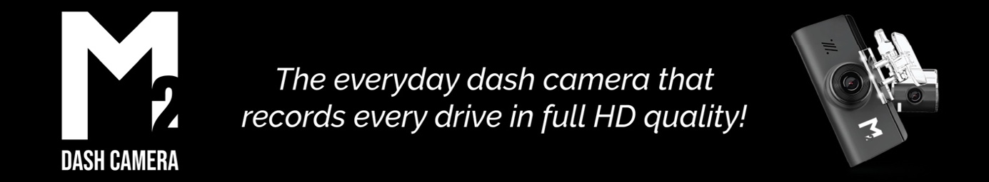

Benefits:
- 3 year back-to-base warranty^
- Available as a standard front or rear configuration
- Records both audio and visual footage

- Comes with a 32GB SD card
- Professionally installed by a trained technician
- Real-time check voltage.
*^T&C's apply.﻿

Delivery Package: | Individual Costings (RRP)
Protektiv HYDRO Exterior Surface Coating | Valued at $0,000
Protektiv HYDRO Leather Coating | Valued at $0,000
Protektiv HYDRO Fabric + Carpet Coating | Valued at $0,000
Protektiv HYDRO Vinyl Coating | Valued at $0,000
SCHMICK X- Year Membership | Valued at $0,000
M2 Front & Rear Dash Camera | Valued at $0,000

Normally valued at $0000, this premium delivery package is on special for just $0000.
﻿﻿﻿We know that our customers like to take care of their new vehicles but free time is limited these days. This premium package gives you an ease of clean and a greater peace of mind by being covered with a national lifetime guarantee*.
I will call you this afternoon for a brief 5-10 minute chat so you can let me know how you would like me to proceed in preparing your new vehicle for delivery.
﻿﻿﻿﻿
#There are some restrictions on repair location.﻿ *Warranty term, conditions and exclusions apply.

Kind Regards,  [Name]  [Dealership Name] | [Address Details]  [Phone Number]  [Website address

