<Insert Dealer Logo>

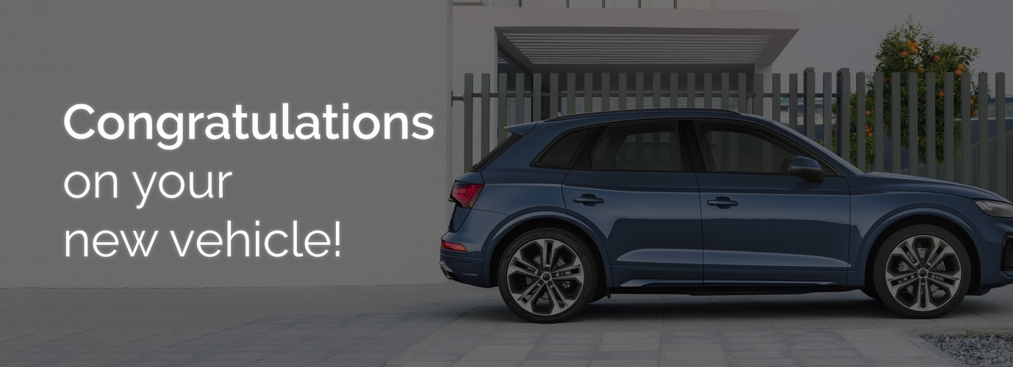
Good afternoon XXX,﻿
My name is <XXX> from <DEALERSHIP> and I will be preparing your new <VEHICLE BRAND> for delivery.
Please find below some important information regarding our Premium Delivery Package, which may be of interest before taking delivery of your new car.

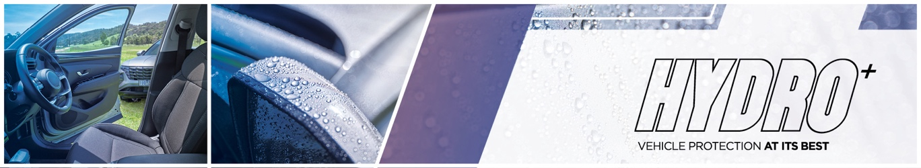
The HYDRO+ package will enhance the everyday appearance of your new vehicle while also providing a limited lifetime warranty* for painted and interior surfaces. ﻿As the most durable protective product on the market, HYDRO+ has many benefits:
- Helps protects against contaminants such as bird droppings, tree sap, sunscreen and more,
- Has had over 600 hours of product testing,
- Made from a high performing formula combining Silicon Carbide (SiC) and Ceramic,
- ﻿﻿Retains that showroom shine over the period of ownership,
- Backed by a lifetime warranty.

Watch this short video to see the product in action. | 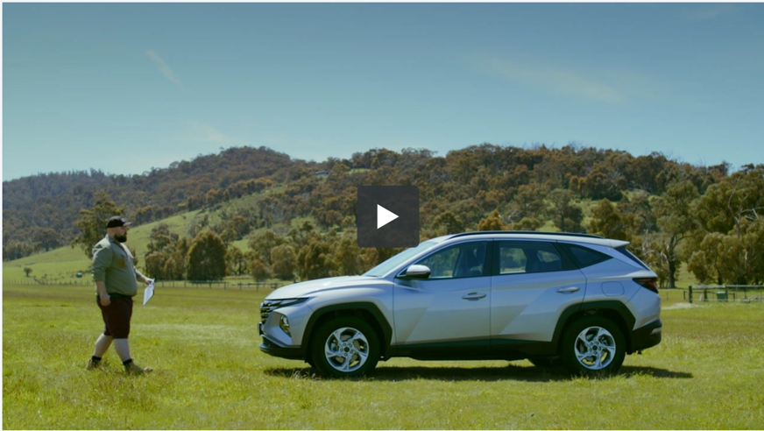
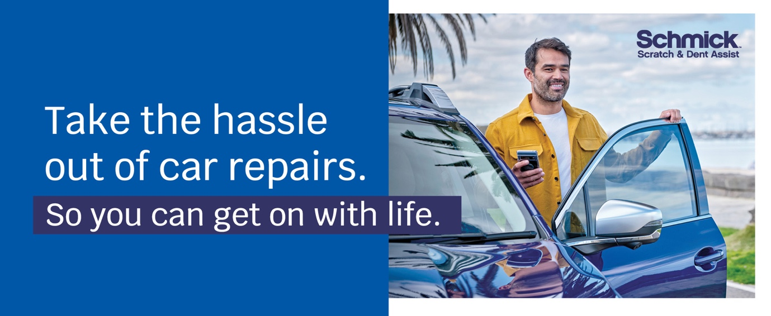
Have you considered a Schmick membership? Australia’s fastest growing, most cost-effective and convenient solution for repairing minor scrapes, scratches and dents on motor vehicles is Schmick Scratch & Dent Assist. Our National fleet of mobile repair vans can come to you at your home, or at your place of work#.
﻿Our industry-qualified tradesmen use the latest in Small Accident Repair Technology so you can be sure your vehicle is in excellent hands. ﻿Keeping your car looking as good as new, inside and out, is easy with Schmick Scratch & Dent Assist and the benefits and savings are significant.

Watch this short video on Schmick Scratch & Dent Assist! | 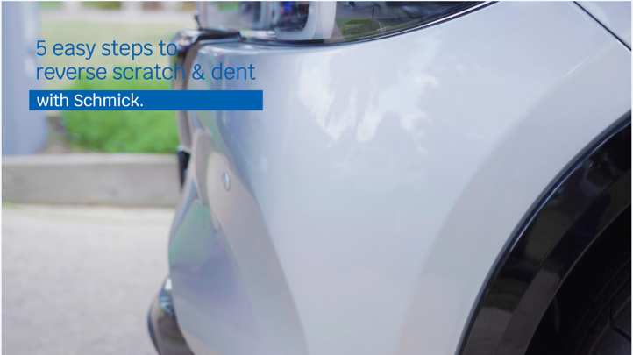
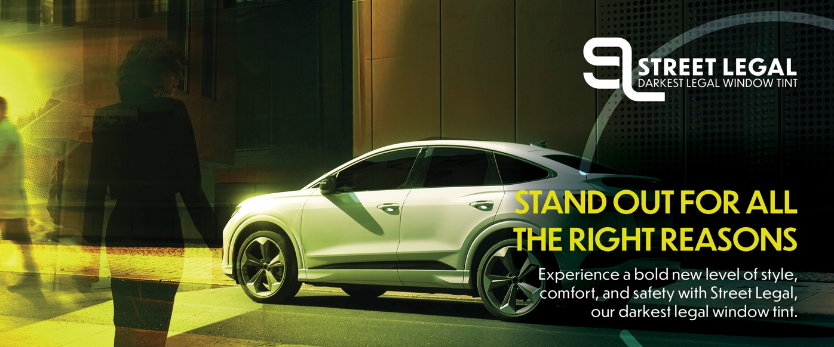

Currently your XXX has clear glass. We recommend you tint the full vehicle with Street Legal window film - the darkest window film for your vehicle, creating a look that will turn heads. |  | ﻿Benefits:  - ﻿﻿60% Glare rejection for maximum safety  - 99% UV rejection for maximum protection  - 60% Solar rejection for maximum comfort  - 35% Light transmitted for maximum privacy
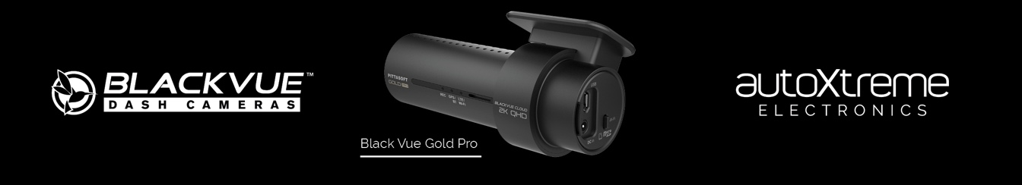
We want to ensure our customer’s have the latest information on driver safety and security - Introducing BlackVue Gold Pro with 2K quality quad HD recording, this dash camera is both first-class design impressive technology. |  | Benefits:  - ﻿﻿Full coverage - front & rear cameras ensure maximum coverage  - Instant replay - view the footage via the iOS or Android App  - 5 year nationwide warranty*^  *^T&C's apply.﻿
Delivery Package: | Individual Costings (RRP)
HYDRO+ Exterior Surface Coating | Valued at $0,000
HYDRO+ Leather Coating | Valued at $0,000
HYDRO+ Fabric + Carpet Coating | Valued at $0,000
HYDRO+ Vinyl Coating | Valued at $0,000
SCHMICK X- Year Membership | Valued at $0,000
Street Legal Window Film | Valued at $0,000
BlackVue Gold Pro Front & Rear Dash Camera | Valued at $0,000

Normally valued at $0000, this premium delivery package is on special for just $0000.
﻿﻿﻿We know that our customers like to take care of their new vehicles but free time is limited these days. This premium package gives you an ease of clean and a greater peace of mind by being covered with a national lifetime guarantee*.
I will call you this afternoon for a brief 5-10 minute chat so you can let me know how you would like me to proceed in preparing your new vehicle for delivery.
﻿﻿﻿﻿
#There are some restrictions on repair location.﻿ *Warranty term, conditions and exclusions apply.

Kind Regards,  [Name]  [Dealership Name] |  |  | [Address Details]  [Phone Number]  [Website address

