<insert dealer logo>
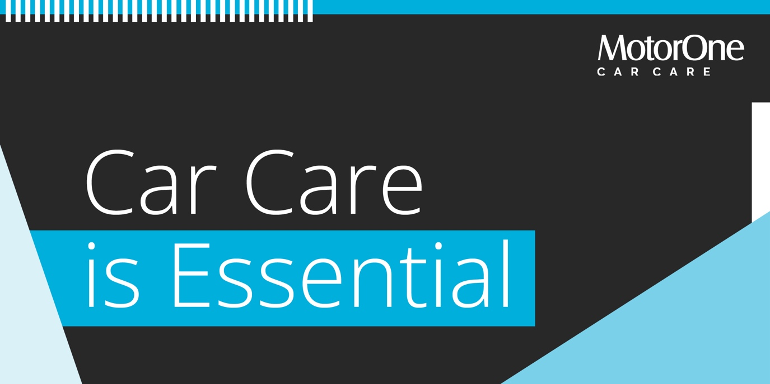

Good afternoon XXX,

My name is <XXX> from <DEALERSHIP> and I wanted to congratulate you on taking delivery of your new <VEHICLE BRAND>.

Car Care is essential for every car owner so please find below some important information regarding our Premium Delivery Package, which should be of interest to you.
For you exterior and interior protection.

HYDRO G9+ is our latest ceramic surface coating with Graphene. It’s key features are that it:
- Maintains showroom shine.
- Reduces the need for frequent washing.
- Covers your interiors whether they are vinyl, leather, fabric or carpet.
- Is backed by a nationwide limited lifetime warranty*.

Watch the demonstration here

For your privacy and protection.

Your car currently has clear glass. Street Legal delivers a look that will turn heads with the added benefits of:
- Dramatically reduces UV exposure for your skin.
- Reduces heat.
- Holds shattered glass together in the event of an accident .
- Provides an added layer of privacy
- Comes with a lifetime warranty*.

For an extra set of eyes.
M4 Roadview Dash Camera  - 4K Ultra HD quality with Sony Starvis Sensor.  - 128GB memory card.  - Parking mode enabled.  - 5 Year Nationwide Warranty*. | MX Roadview Dash Camera  - 1080P Full HD quality with Sony Starvis Sensor.  - 64GB memory card.  - Sony HDR for clear footage.  - 3 Year Nationwide Warranty*.

For minor scratches and dents.

Schmick Scratch and Dent Repairs take the fuss out of minor repairs.

The key benefits are:
- Unlimited repairs for only $50 each^.
- No loss of car - we come to you!
- Easy booking process via app, phone or email.
- No impact on your car insurance.

See how easy it is to get a repair here

So what are your options?
Delivery Package: | Individual Costings (RRP)
HYDRO G9+ Exterior Surface Coating | Valued at $0,000
HYDRO G9+ Leather Coating | Valued at $0,000
HYDRO G9+ Fabric + Carpet Coating | Valued at $0,000
HYDRO G9+ Vinyl Coating | Valued at $0,000
SCHMICK X- Year Membership | Valued at $0,000
Street Legal Window Film | Valued at $0,000
M4 Roadview Dash Camera | Valued at $0,000
MX Roadview Dash Camera | Valued at $0,000

Normally valued at $0000, this premium delivery package is on special for just $0000.
We know that our customers like to take care of their new vehicles, but free time is limited these days. This premium package gives you an ease of clean and a greater peace of mind.

I will call you this afternoon for a brief 5-10 minute chat so you can let me know how you would like me to proceed in preparing your new vehicle for delivery.

*Warranty term, conditions and exclusions apply. ^Repair fee for a single repair at time of printing. Subject to change. Refer to schmickclub.com for repair fee applicable at the time of requesting a repair.

